# Acknowledgements

I would like to extend my sincere gratitude to Ms. Raquel De Faria Cristas, my supervisor, and Mr. Amir Boutouchent, manager of the IAM team, for their invaluable support and guidance throughout my internship. Their dedication to my professional development, particularly during the Knowledge Transfer period, provided me with crucial insights and practical skills that have been instrumental in my growth. Their guidance was particularly helpful in shaping my work methodology.

My sincere thanks also go to Professor Chaimaa Kissi, my supervisor at ENSA-K, for his unwavering support and guidance throughout my final year project. Her mentorship was invaluable in helping me achieve the objectives of my internship.

I would like to express my appreciation to the entire IAM team at DELOITTE MOROCCO CYBER CENTER, especially Mr. Ayoub Assaid and Mr. Yassine Taki. It has been a privilege to learn from and collaborate with such a talented and dedicated team.

I am grateful to the entire faculty of ENSA-K for their commitment to my education during these past three years. I extend my thanks to the members of the jury for their thoughtful and insightful feedback on my work. Finally, I acknowledge the support of all those who have contributed, directly or indirectly, to the completion of this project.

Je tiens à exprimer ma sincère gratitude à Mme Raquel De Faria Cristas, ma mon encadrante, et à M. Amir Boutouchent, Manager de l'équipe IAM, pour leur soutien et leurs conseils précieux tout au long de mon stage. Leur dévouement à mon développement professionnel, en particulier pendant la période de transfert de connaissances, m'a permis d'acquérir des connaissances cruciales et des compétences pratiques qui ont été essentielles à mon évolution. Leurs conseils ont été particulièrement utiles pour façonner ma méthodologie de travail.

Je remercie sincèrement également ma Professeure Chaimaa Kissi, mon encadrante à l'ENSA-K, pour son soutien indéfectible et ses conseils tout au long de mon projet de fin d'études. Son mentorat a été précieux pour m'aider à atteindre les objectifs de mon stage.

Je tiens à exprimer ma reconnaissance à toute l'équipe IAM de DELOITTE MOROCCO CYBER CENTER, en particulier à M. Ayoub Assaid et à M. Yassine Taki. C'est un privilège d'avoir pu apprendre et collaborer avec une équipe aussi talentueuse et dévouée.

Je suis reconnaissant envers l'ensemble du corps professoral de l'ENSA-K pour leur engagement envers mon éducation au cours de ces trois dernières années. Je remercie également les membres du jury pour leurs commentaires réfléchis et pertinents sur mon travail. Enfin, je tiens à exprimer ma gratitude à tous ceux qui ont contribué, directement ou indirectement, à la réalisation de ce projet.

Table des matières

General Introduction 5

Chapter 1: Presentation of the host company 7

1.1. Company profile 8

1.2. Risk Advisory 9

1.3. Deloitte Morocco Cyber Center - DMCC 10

1.4. Main department 12

1.5. Conclusion 13

Chapter 2: General context of the project 15

2. General Context 16

2.1. Project specifications 16

2.1.1. The problem statement 16

2.1.2. Project context 17

2.1.3. Project objectives 17

2.1.4. IAM requirements 18

2.1.5. Zero Trust requirements 18

2.1.6. Deliverables & Timelines 19

2.1.7. Tools used for project management 20

2.2. Study and analysis of cybersecurity standards 21

2.2.1. Regulatory landscape impacting IAM 22

2.2.2. ISO 27001 and NIST CSF 23

2.2.3. The ISO 27001 norm 24

2.2.3.1. Information security management system 24

2.2.3.2. Risk management in ISO 27001 25

2.2.3.3. Identity and access management in ISO 27001 26

2.2.4. NIST CSF 30

2.2.4.1. Maturity Levels 30

2.2.4.2. Roles: 31

2.2.4.3. The Access Control (AC) family: 32

2.3. Benchmark 36

2.4. Plan (Gant diagram) 40

Chapter 3: State of the art 41

3. Zero Trust and Identity and Access Management 42

3.1. Zero Trust 42

3.1.1. History 42

3.1.2. Definition and Concept of Zero Trust 42

3.1.3. Principles and Advantages of Zero Trust 43

3.1.4. Key Components of Zero Trust 46

3.1.5. Zero Trust Architecture according to NIST 47

3.1.6. Limitations of Zero Trust 48

3.2. Identity and Access Management 49

3.2.1. Concepts of IAM 49

3.2.2. Digital Identities 49

3.2.3. Components of IAM 50

3.2.4. Identity Lifecycle 50

3.2.5. Access Management 51

3.2.6. Identity Governance and Administration (IGA) 52

3.2.7. Governance, Risk, and Compliance, and Separation of Duties 53

54

Chapter 4: – Comparative study and presentation of solutions 54

4. Solutions used in our project 55

4.1. Functional architecture 55

4.2. Cerbos 56

4.2.1. What is Cerbos 56

4.2.2. How does it work 57

4.2.3. Cerbos features 61

4.3. Keycloak 66

4.3.1. What is Keycloak 66

4.3.2. How does it work 66

4.3.3. Keycloak features 68

4.3.3. Installation 70

4.4. Project scenario and Use-Cases 73

4.4.3. Scenario 73

4.4.4. Use-cases 73

4.5. Technical architecture and implementation 75

4.5.1. Technical architecture 75

4.6. Implementation 75

4.6.1. Cerbos initial configuration 75

4.6.2. Keycloak initial setup 82

4.6.2.1. Keycloak server deployment 82

4.6.3. OpenLDAP Configuration with Keyclaok for User Federation 87

4.6.3.1. Adding an OpenLDAP directory to Keycloak 87

4.6.4. Application Development 95

4.6.4.1. Application architecture 95

4.6.4.2. Keycloak API 95

4.6.4.3. Cerbos API 96

4.6.4.4. Maxmind API 98

4.7. Test and Results of the Use Cases 99

4.7.1. Use Case 1: Application of the principle of least privilege 99

4.7.2. Use Case 2: Context based access control 100

4.7.3. Use Case 3: Authentication using MFA. 102

Overall conclusion 104

# General Introduction

This internship report describes my experience at Deloitte Morocco Cyber Center, where I conducted an internship focusing on the theme of Zero Trust in access and identity management. This internship is part of my academic training and was carried out with the aim of developing a demonstrator of IAM tools offering Zero Trust functionalities.

The report is structured into four chapters, covering the different stages of my internship. The first chapter is dedicated to the presentation of my host company, Deloitte Morocco Cyber Center. We will examine its position in the cybersecurity market as well as its areas of expertise.

The second chapter addresses the general context of the project. We will discuss the current challenges in information security and the necessity for organizations to have a robust Zero Trust approach. We will highlight the challenges and opportunities that motivated the development of this demonstrator, as well as the objectives set for its design. We will also conduct a study on the ISO 27001 and NIST CSF standards to understand the regulatory requirements for a secure IAM architecture, which will allow us to conceptualize criteria for our solutions benchmark. After that, we will present our action plan or implementation steps and the internship schedule (Gantt diagrams).

The third chapter is dedicated to the state of the art, where we will present and explain the concepts of Zero Trust, conduct a study on the different technologies used in access and identity management.

Finally, the fourth chapter focuses on a detailed study of the project and the implementation and deployment of the demonstrator. We will describe in detail the functional and technical architecture of the demonstrator, focusing on the different phases of its development, the methodologies used, and the key elements that compose it. We will also explain how these tools can be applied in a real environment to enhance the information security of an organization. We will present the various steps to follow for the implementation of the different tools, highlighting the results obtained, the difficulties encountered, and the lessons learned. We will also discuss perspectives and recommendations for the continuous improvement of the demonstrator.

The purpose of this internship report is to provide an overview of my experience at Deloitte Morocco Cyber Center, as well as the results obtained in the development project of an IAM tools demonstrator proposing a Zero Trust architecture. It represents an opportunity to share the knowledge and learning acquired during this internship period, while highlighting the technical and professional skills developed.

It should be noted that certain specific information regarding the host company and client projects has been omitted or anonymized to comply with confidentiality obligations. However, this does not affect the overall understanding of the report, or the presentation of the results obtained.

In the following sections of this report, we will discuss each chapter in detail, highlighting the key aspects of the project and providing in-depth analyses.

# Chapter 1: Presentation of the host company

1. Introduction

In this first chapter, we introduce the hosting organization, which is the company providing the project. We briefly present the technical specifications of the company, highlighting key information such as its name, address, and size. Next, we delve into the business areas of the company, emphasizing the sectors in which it conducts its main activities. Finally, we provide an overview of the structure and general organization of the company, highlighting the departments and teams that make it up. These pieces of information provide essential context for the remainder of our study.

## Company profile

In the following, we present the multinational organization Deloitte, its subsidiary in Morocco, Deloitte Morocco Cyber Center, and the IAM team that accompanied me in completing our internship projects.

The term "Big Four" is used to collectively refer to the four largest audit firms in the world, namely Deloitte, Ernst & Young, KPMG, and PwC. Deloitte is renowned for being the oldest and largest of these four major firms, with over 175 years of excellence. Its revenue reached $64.9 billion and had 457,000 employees in 2023, covering more than 150 countries.

Deloitte harnesses a diverse set of skills to address the challenges of its clients, of all sizes and sectors, aiming for the highest quality in providing services and professional advice across various domains:

Table 1.1: Deloitte Services

|  |  |
| --- | --- |
| Audit and Assurance | Financial audit involves providing an opinion on the financial information made available to financial markets and various stakeholders of the company. |
| Consulting | Meeting the demands of a complex and changing regulatory landscape while remaining flexible, even extending to outsourcing. |
| Financial Advisory | Assisting companies in mastering their financial risks and managing their scarce resources by combining skills in organization, modeling, and processes, leveraging proven tools. |
| Legal | Helping companies control and manage their operations, third parties, data, and projects. |
| Tax | Offering innovative solutions that combine expertise in complex legal and tax issues with an economic and financial culture, enabling an appropriate response to the strategic challenges of businesses. |
| Risk Advisory | Deloitte assists its clients in understanding, assessing, modeling risks to make informed decisions. |

## Risk Advisory

Brand image, impact of the company on the environment, compliance with a complex regulatory environment, protection of digital assets—Deloitte supports its clients in managing all these risks, which revolve around 5 main categories:

Table 1.2: Risk Categories within Risk Advisory

|  |  |
| --- | --- |
| STRATEGIC RISK | Assisting companies in identifying and managing risks with a high impact on their strategy by addressing governance, reputation, and sustainable development. |
| REGULATORY RISK | Addressing the demands of a complex and evolving regulatory landscape while remaining flexible, even extending to outsourcing. |
| FINANCIAL RISK | Assisting companies in mastering their financial risks and managing their scarce resources by combining skills in organization, modeling, and processes, leveraging proven tools. |
| OPERATIONAL RISK | Helping companies control and manage their operations, third parties, data, and projects. |
| CYBER RISK | Anticipating increasingly probable cyber threats with a strategic approach to vigilance and resilience. |

## Deloitte Morocco Cyber Center - DMCC

The **DELOITTE MOROCCO CYBER CENTER** is a Cyber Intelligence center equipped with a pool of cybersecurity specialists, technologies, and services to meet the growing demand for cyber expertise and to expand Deloitte Global's service offerings on the African continent.

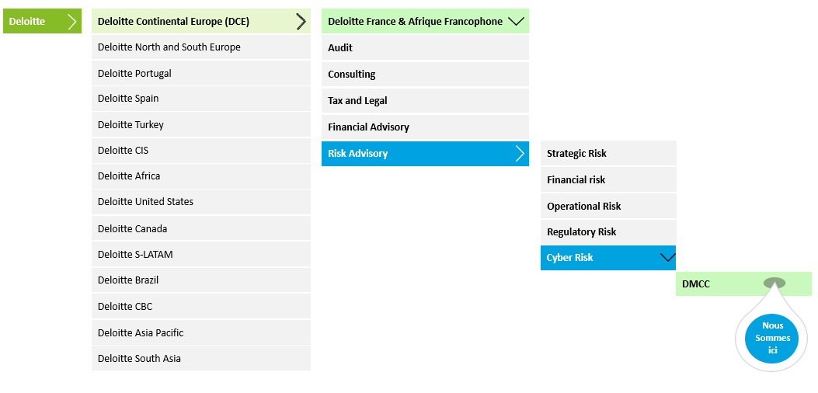

Figure 1.3: Deloitte Morocco Cyber Center’s position

The **DMCC** is the first cyber center in Africa to offer cyber services in compliance with best cybersecurity practices. Situated in the heart of **Casablanca Finance City**, known as the first financial and technological hub in Africa, the DMCC aims to promote the employment of Moroccan experts and engineers graduated from top engineering schools and universities in Morocco by providing them with the best working environment and opportunities to develop their skills. Additionally, it aims to develop a local **cybersecurity ecosystem** that will have a national, regional, and global impact.

As part of a network of Deloitte cyber service centers, with a **24/7 operational** mode and a workforce of over **120 experts** in the field, the DMCC provides managed services and close support to its clients worldwide across various departments covering all cybersecurity activities.

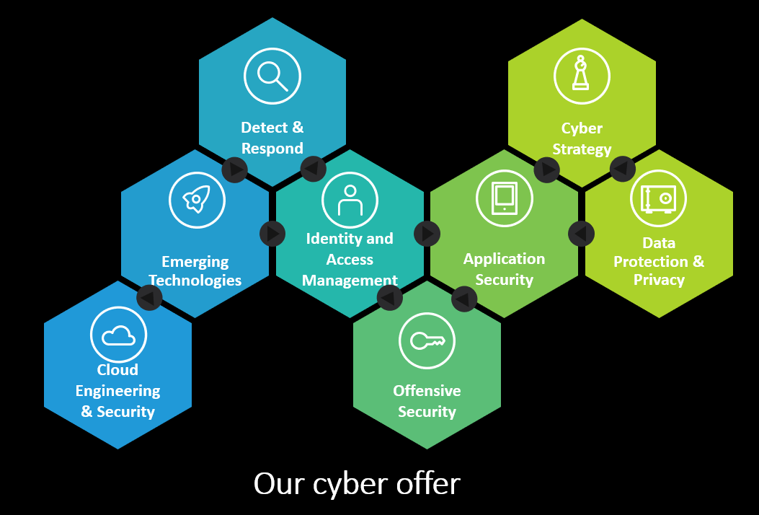

Figure 1.: Services of DMCC

* **Identity & Access Management:** Helping customers ensure both identity and access security, and a seamless user experience,
* **Cyber Strategy:** Helping customers to align their ideal cyber strategy with their strategic objectives across the entire scope of the company,
* **Detect & Respond:** Implement cyber defense and incident management programs to face, protect and remediate cyber-attacks,
* **Cloud Security:** Successfully migrate all of a company's business processes to the Cloud in a secure and private way,
* **Data & Privacy:** To assist in the management of the personal, sensitive, and confidential information that our customers collect, process and share,
* **Application Security:** Securing applications throughout the system development lifecycle,
* **Emerging Technologies:** Securing next-generation technologies, such as the Internet of Things (IoT) and Industrial Control Systems (ICS),
* **Offensive Security:** Helping organizations assess their resilience to cyberattacks by testing and examining their systems.

## Main department

The department in which I interned is the Identity & Access Management (IAM) department which aims to help customers with identity and access governance and management in an era where cybersecurity is pervasive. Deloitte supports the design, analysis, and implementation of IAM processes that ensure reliable governance and operational management of identities and access based on market-recognized frameworks in its projects to strengthen the maturity of IAM policies, and makes its technology expertise and in-depth knowledge of the market available to its clients, thus allowing you to apprehend current issues with serenity, including:

* + Identity and access federation in the cloud.
  + The choice and typology of IAM tooling.
  + Security and authentication policies.
  + The adaptability and quality of IAM processes.
  + Control of access to sensitive resources.
  + Compliance with legislative frameworks facilitated by IAM/IAG tooling.

Here are some of the solutions we work with at DMCC:

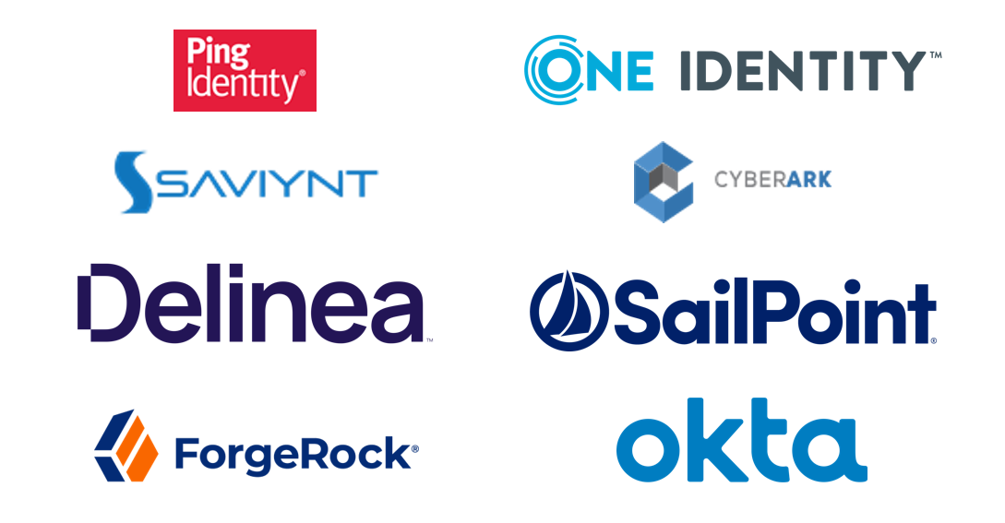

Figure 1.5: IAM solutions used at Deloitte.

Given the rapid evolution of businesses and information systems towards greater openness and synergy, Deloitte provides the business and technological expertise necessary to meet the challenges related to the digital transformation of its clients:

* + Identity federation, integration of subsidiaries and openness to partners.
  + Asset protection, enhanced data security.
  + Improvement of the integration processes of newcomers.
  + Integration of corporate policies in terms of access management and sensitive clearances.
  + Compliance with industry-specific compliance frameworks.
  + Control of organizational and operational costs and risks.

In an environment where cybercrime threats and risks are increasingly present, it is essential for organizations to develop a robust cybersecurity strategy that meets their specific needs and is aligned with their overall goals.

The IAM department focuses on this strategic and technical dimension by working closely with clients to understand their goals, challenges, and priorities.

## Conclusion

In conclusion, this first chapter allowed us to lay the foundations of our internship report by presenting the host organization, the Cyber team of the Risk Advisory department and the IAM department to which I was attached. We also described the course of my internship period, highlighting the different stages and activities in which I participated.

This chapter was essential in contextualizing our internship experience and providing a clear understanding of the environment in which we operated. It highlighted the importance of cybersecurity and cybersecurity strategy in today's businesses, where cybercrime risks are pervasive.

Through our integration into the IAM team, we have been able to develop our knowledge and skills in the field of cybersecurity, familiarizing ourselves with international standards and best practices. We also had the opportunity to put our knowledge into practice by participating in a client mission, where we saw the concrete impact of our work on improving the safety and quality of work within the client company.

This first chapter lays the groundwork for future chapters, where we will delve deeper into the details of our project, the methodologies used, the results achieved, and the lessons learned from our internship experience.

# Chapter 2: General context of the project

## General Context

## Project specifications

The goal of this project is to create an interactive demonstrator to illustrate how Zero Trust architecture can improve and facilitate identity and access management (IAM). This demonstrator will serve both as an educational tool for internal teams and customers, as well as a proof of concept to demonstrate the effectiveness of Zero Trust strategies in IAM management.

## The problem statement

A company's infrastructure has become increasingly complex. A single company can operate multiple internal networks, remote offices with their own premises, remote and/or mobile individuals, and cloud services. This complexity has surpassed the old methods of perimeter-based network security, as there is no single, easily identifiable perimeter for the enterprise. Perimeter-based network security has also proven to be insufficient because once attackers breach the perimeter, any further lateral movement is free.

For this reason, most organizations have thought about replacing perimeter-based network security with the defense in-depth model. It refers to a cybersecurity approach that uses multiple layers of security for holistic protection. A layered defense helps security organizations reduce vulnerabilities, contain threats, and mitigate risk. In simple terms, with a defense-in-depth approach, if a bad actor breaches one layer of defense, they might be contained by the next layer of defense.

But it’s no longer sufficient in today's rapidly evolving threat landscape. Relying solely on layers of defense to protect sensitive data and systems can create a false sense of security, as attackers are becoming increasingly sophisticated in bypassing traditional security measures. Moving towards a zero-trust approach is essential to adapt to this new world of security.

Zero Trust is a security policy that states that no entity (user, application, service, or device) should be trusted by default. Under the principle of least-privilege access, trust is established before any connection, based on the entity's context and security posture, and then continuously re-evaluated for each new connection, even if the entity has already been authenticated before.

## Project context

In response to the rise of the zero-trust policy and its growing adoption across companies, we decided to create a tool that can demonstrate zero trust capabilities in the identity and access management field and assess its functionality and compatibility with IAM solutions.

Based on Deloitte’s requirements, we gathered information about 4 Policy Decision Points (PDP) that offer zero trust capabilities and created a benchmark comparing them, two of those are proprietary options (PlainID and Axiomatics), and two open-source solutions (OPA + OPAL and Cerbos). This tool was only going to use open-source solutions and so for that we chose Cerbos for our IAM architecture because it fits the Zero Trust and IAM requirements better, so it stands out as the best solution for our demonstrator.

In order to bring this project to life, we needed to have some fictional use cases for our tool. We created six use cases showcasing different functionalities of zero-trust and identity and access management. Each one of them illustrates a scenario where IAM solves security problems for a fictional company and protects against various threats and attacks.

Finally, we created the functional architecture of the system with all the solutions that will be used to make it operational which include the main application, the identity provider, the PDP, the identity sources, and other systems like SIEM and MFA.

## Project objectives

To ensure a successful outcome, Deloitte has identified the following key objectives for this project:

* Identification of benefits from a regulatory and security perspective of the Zero Trust approach.
* Identification of the most relevant market solutions: Choose evaluation criteria and benchmark the publisher and open-source solutions on the market to identify the most relevant for our demonstrator.
* Interactive Demo: Create an interactive interface that simulates user access scenarios using Zero Trust principles to manage identities and access.
* Training and Awareness: Provide an educational tool to educate teams and customers on the benefits of Zero Trust architecture in IAM.
* Proof of Concept: Demonstrate how Zero Trust improves the security and efficiency of IAM management.

## IAM requirements

Aligned with the IAM requirements from standards and regulations, Deloitte has defined the following specific requirements for this project:

* Identity Lifecycle Management: Provisioning, managing, and deprovisioning user accounts throughout their lifecycle, including creation, modification, and deletion.
* Authentication: Verifying users' identities with the identity sources through their credentials.
* Authorization: Control access to resources based on the permissions and roles assigned to individual users or groups, ensuring that users have the appropriate access privileges.
* Policy-Based Access Control (PBAC): Assigning permissions to users based on policies determined in the PDP, simplifying access management, and enforcing the principle of least privilege.
* Audit: The ability to generate logs and export them to external SIEM systems to monitor user activities, access events and generate reports.

## Zero Trust requirements

In order to achieve Zero Trust functionalities, the following requirements are extremely important. This project will include Zero Trust features that can be done with an IAM architecture.

* Least privilege access: Reduces security risks by restricting user access to resources critical to their specific function, thereby minimizing opportunities for attacks and data leaks.
* Context based access: Enhances security by assessing the risk of login attempts based on the context (location and access time) and applies additional authentication measures based on that level of risk. This helps prevent unauthorized access to sensitive resources.
* Continuous authentication and MFA: Helps make access more secure by requiring multiple forms of authentication, while continuous authentication actively monitors user activity to prevent unauthorized access.
* Resource segmentation: Enhances security by reducing the attack surface and limiting unauthorized access to sensitive resources. This helps protect valuable company data from intrusion attempts.
* Unauthorized access attempts monitoring: Provides granular and rapid detection of threats and suspicious activity or unauthorized access to sensitive data, enabling security teams to respond quickly and strengthen their security posture.
* User behavior analysis: Enables early detection of suspicious activity, which helps prevent security breaches. By quickly identifying anomalous behaviors such as unusual access to sensitive resources, corrective actions can be taken to minimize potential damage.

## Deliverables & Timelines

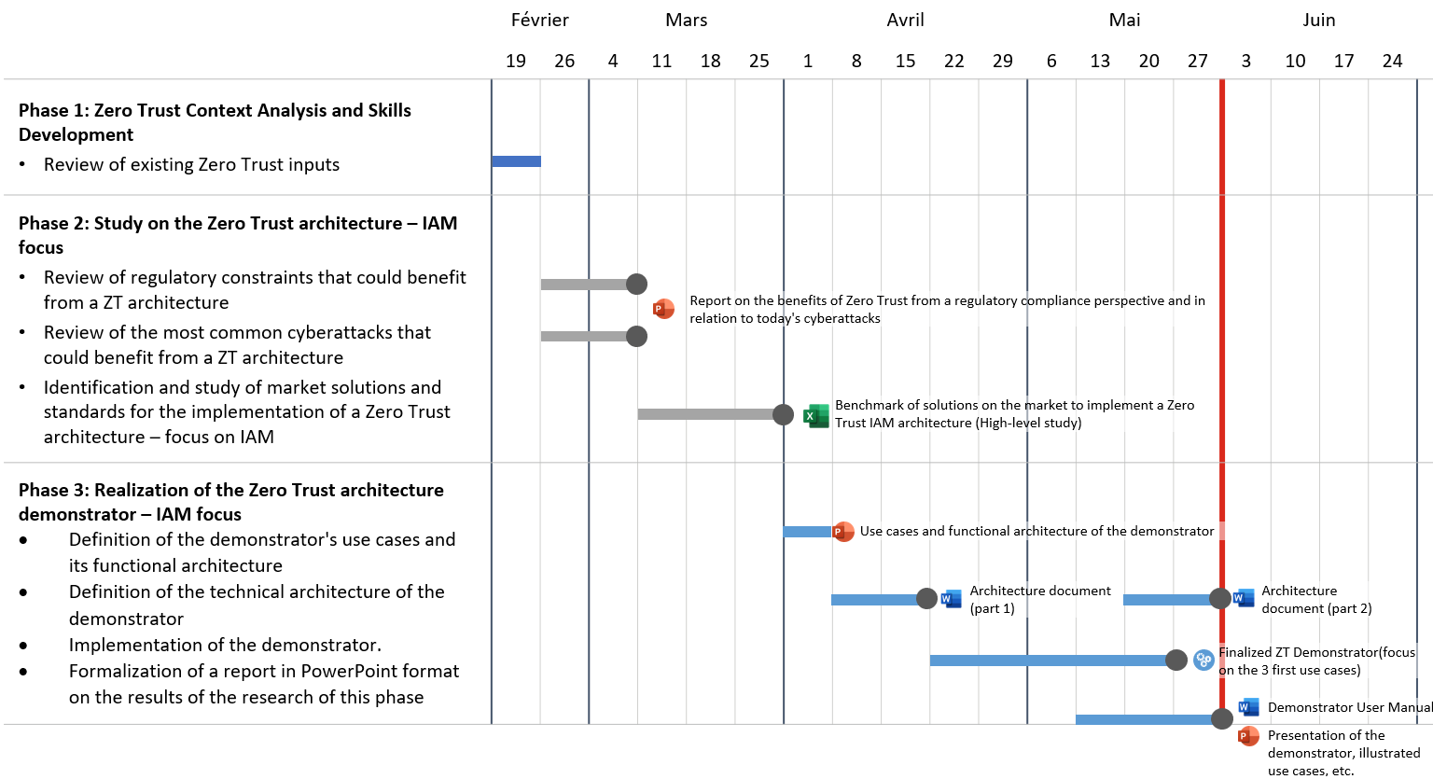

Figure 2.1: The timeline of deliverables

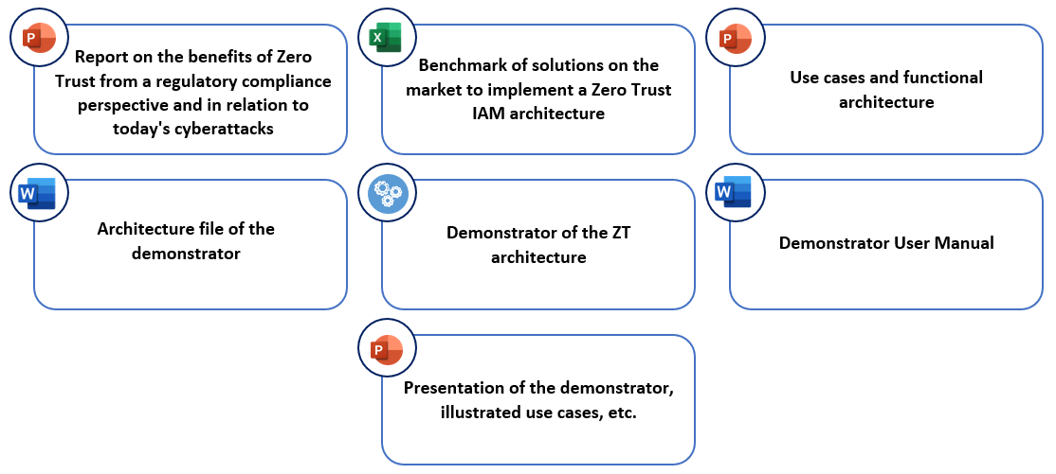

Figure 2.2: List of deliverables at the end of the project

## Tools used for project management

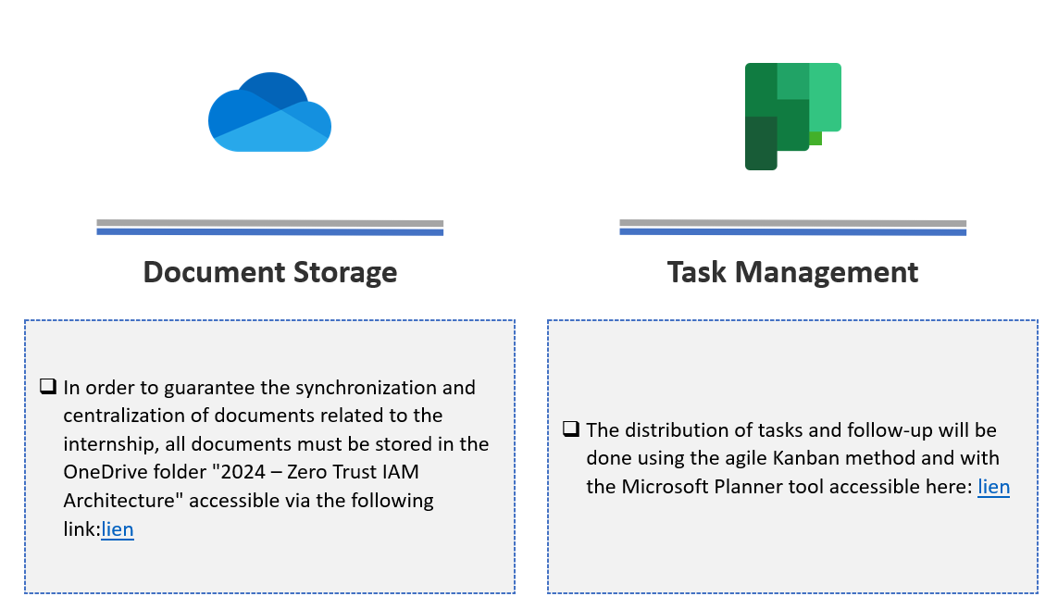 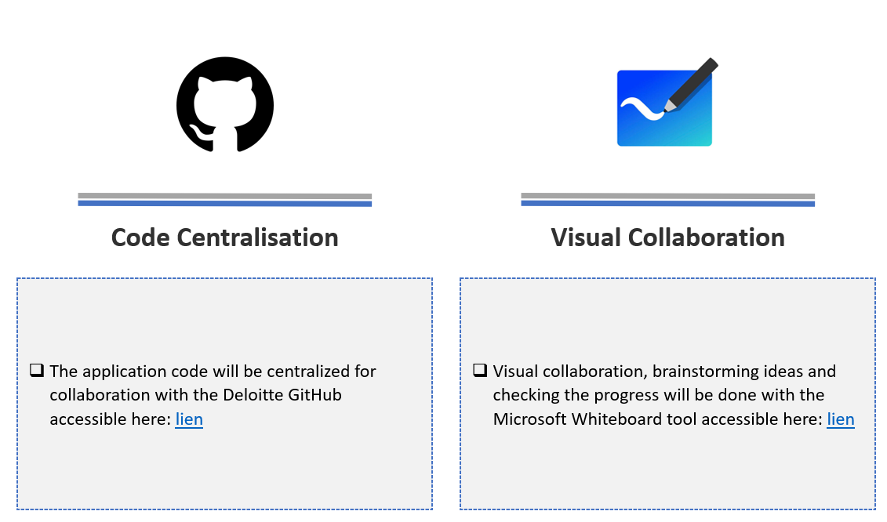

Figure 2.3: Project management tools used for this project

## Study and analysis of cybersecurity standards

In this part of our study, we will look at different standards, regulations and frameworks that address IAM security. After presenting various standards and their overall impact on IAM, we will focus on two of the most famous and widely used standards, ISO 27001 and NIST CSF.

By studying the controls that address IAM security, we will be able to extract the most important criteria to compare IAM solutions for our project.

## Regulatory landscape impacting IAM

This section of our research dives into the relationship between Identity and Access Management (IAM) and the evolving regulatory landscape. We present a comprehensive table outlining key standards and regulations alongside concise definitions. This analysis aims to illuminate the significant impact these frameworks and standards have on IAM practices, fostering a deeper understanding within our study.

|  |  |  |
| --- | --- | --- |
| **Standard/Framework** | **Region** | **Impact on IAM** |
| **General Data Protection Regulation (GDPR)** | European Union | Requires strict controls on access to personal data, ensuring data privacy and protection. |
| **Health Insurance Portability and Accountability Act (HIPAA)** | United States | Involves the protection of patients' health information, requiring IAM systems that ensure access only to authorized healthcare professionals. |
| **Payment Card Industry Data Security Standard (PCI DSS)** | Global | Requires strict access control measures for systems handling cardholder data, including unique identifiers and strict password policies. |
| **Federal Risk and Authorization Management Program (FedRAMP)** | United States | Establishes a standardized approach for assessing the security of cloud products and services used by federal agencies, requiring robust IAM controls. |
| **NIST Cybersecurity Framework (CSF)** | United States | Provides a framework to improve cybersecurity risk management, including IAM practices to identify, protect, detect, respond to, and recover from security threats. |
| **NIST Special Publication 800-53 (Security and Privacy Controls for Information Systems and Organizations)** | United States | Provides a catalog of security and privacy controls, including IAM requirements, that is widely used in both federal and private sectors. |
| **Sarbanes-Oxley Act (SOX)** | United States | Strengthens internal controls and audit procedures, including user access controls to ensure the integrity of financial reporting. |
| **ISO/IEC 27001 (Information Security Management)** | Global | An international standard for information security management systems (ISMS), with a strong focus on IAM. |
| **ISO/IEC 27002 (Code of Practice for Information Security Management)** | Global | Complements ISO/IEC 27001 by providing detailed guidance for best practices in information security management, including IAM. |
| **California Consumer Privacy Act (CCPA)** | United States (California)) | Strengthens consumer privacy rights and protection, requiring access controls to protect personal data and allowing consumers to request information about access to their data. |
| **Critical Security Controls (CIS Controls)** | Global | A set of best practices for cybersecurity, including IAM controls such as inventory of authorized and unauthorized devices and software, secure configuration, and controlled use of administrative privileges. |
| **Gramm-Leach-Bliley Act (GLBA)** | United States | Requires financial institutions to protect sensitive customer data, requiring IAM systems that ensure access only to authorized individuals. |

## ISO 27001 and NIST CSF

ISO 27001 and NIST CSF are two popular frameworks that organizations use to enhance their cybersecurity posture and manage information security-related risks. Although they have similar objectives, they come from different sources and have distinct characteristics. These two standards have been chosen for the following reasons:

**Strengths of the ISO 27001 standard:**

- International recognition: It is an internationally recognized standard, meaning that certified organizations can demonstrate their compliance with global information and security standards.

- Continuous improvement: The ISO 27001 framework encourages organizations to adopt a continuous improvement approach to information security, requiring them to regularly assess risks, implement appropriate security measures, and monitor their effectiveness.

- Comprehensive framework: ISO 27001 provides a comprehensive framework for information security management.

**Strengths of the NIST CSF standard:**

- Flexibility: The NIST CSF is a flexible framework that can be tailored to the specific needs and risks of each organization.

- Alignment with regulations and standards: The NIST CSF is developed by the National Institute of Standards and Technology (NIST), a US government agency. Therefore, it is often aligned with cybersecurity regulations and standards.

- Common language and collaboration: The NIST CSF provides a common language and communication structure for discussing cybersecurity within the organization and with external stakeholders.

## The ISO 27001 norm

## Information security management system

The Information Security Management System (ISMS) is a framework of policies, procedures, and processes designed to manage risks related to an organization's information security and protect sensitive information. The International Organization for Standardization (ISO) 27001 standard proposes a structured approach to implementing an ISMS and effectively managing information security risks.

The ISMS of the ISO 27001 standard is based on the Plan-Do-Check-Act (PDCA) cycle, which is a process of continuous improvement designed to ensure that the ISMS is effective and aligned with the organization's objectives. The PDCA cycle consists of four phases:

* **Plan:** In this phase, the organization establishes the objectives and processes necessary to manage information security risks. This involves identifying information security risks, determining the scope of the ISMS, and developing a risk management plan.
* **Do:** During this phase, the organization implements the processes and controls necessary to manage information security risks. This includes implementing identity management controls, as well as other security controls aimed at protecting sensitive information.
* **Check:** In this phase, the organization monitors and evaluates the effectiveness of the ISMS. This involves conducting audits and regular reviews to identify issues and improvement opportunities.
* **Act:** During this phase, the organization takes actions to improve the ISMS based on the results of the monitoring and evaluation phase. This involves modifying processes and controls to address identified issues and improve the overall effectiveness of the ISMS.

## Risk management in ISO 27001

When designing its information security management system, the organization must consider the issues and requirements and determine the risks and opportunities that need to be addressed to prevent or limit the impact of an incident. The following figure illustrates the organization of risks in ISO 27001:

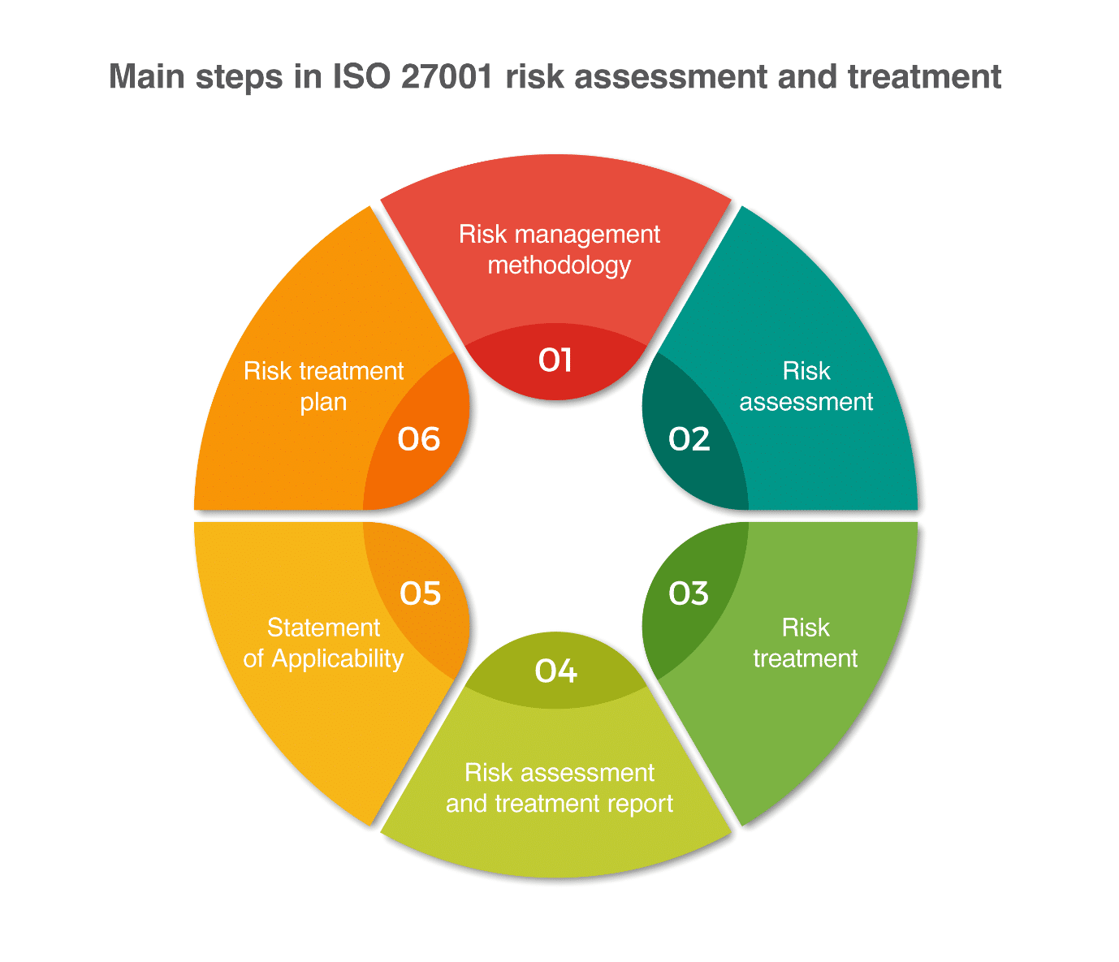

## Identity and access management in ISO 27001

Managing identities is an important aspect of information security management, and it is addressed in the ISO 27001 standard within the framework of the Information Security Management System (ISMS). ISO 27001 requires organizations to identify and manage risks associated with the use of identities, both within the organization and with external parties. This includes ensuring that user, device, and system identities are effectively managed and controlled to prevent unauthorized access to sensitive information. Specifically, the following controls are relevant for identity management in the ISO 27001 standard:

|  |  |  |
| --- | --- | --- |
| A.9 Access control | | |
| A.9.1 Business requirements for access control | | |
| Objective: To limit access to information and information processing facilities. | | |
| A.9.1.1 | Access Control Policy | An access control policy should be established, documented, and reviewed based on business and information security requirements |
| A.9.2 User Access Management | | |
| Objective: To control user access through permissions and prevent unauthorized access to information systems and services. | | |
| A.9.2.1 | User Registration and Opt-Out | A formal process for registering and unregistering users must be implemented to allow access rights to be assigned. |

|  |  |  |
| --- | --- | --- |
| A.9.2.2 | Distribution of access to users | A formal process of distributing access to users must be implemented to assign and remove access rights to all types of users across all services and systems. |
| A.9.2.3 | Managing privileged access rights | The allocation and use of privileged access rights must be restricted and controlled. |
| A.9.2.4 | Managing User Authentication Secrets | The assignment of authentication secret information must be performed as part of a formal management process. |
| A.9.2.5 | Review of user access rights | Review of user access rights |
| A.9.2.6 | Removal or adaptation of  Access rights | The rights of access to information and information processing of all employees and third-party users must be deleted at the end of their period of employment or adapted in the event of a change in the contract or agreement. |
| A.9.4 Control of access to the system and information | | |
| Objective: To prevent unauthorized access to systems and applications. | | |
| A.9.4.1 | Restriction of access to information | Access to information and system application functions must be restricted in accordance with the access control policy. |
| A.9.4.3 | Word Management System  Pass | Systems that manage passwords must be interactive and must guarantee the quality of passwords. |
| A.9.4.4 | Using Privileged Utility Programs | The use of utility programs to bypass the security measures of a system or application should be limited and tightly controlled. |
| A.6 Information Security Organization | | |
| A.6.1 Internal organization | | |
| Objective: To establish a management framework to initiate and verify the implementation and operational operation of information security within the organization. | | |
| A.6.1.1 | Information Security Duties and Responsibilities | All responsibilities for information security must be defined and assigned. |
| A.6.1.2 | Segregation of duties | Incompatible tasks and areas of responsibility should be siloed to limit the potential for unauthorized or unintended modification or misuse of the organization's assets. |
| A.12 Operational safety | | |
| A.12.4 Logging and monitoring | | |
| Objective: Record events and generate evidence. | | |
| A.12.4.1 | Event logging | Event logs recording user activities, exceptions, failures, and information security events should be created, maintained, and checked regularly. |

The ISO27001 controls outlined in the table contribute significantly to achieving Zero Trust functionalities by implementing granular access control mechanisms and robust security practices. The principle of "least privilege" is enforced through controls like "Segregation of duties", "Managing privileged access rights", and "User Registration and Opt-Out". These controls limit user access to only the resources they require, preventing unauthorized access and minimizing the impact of potential breaches. Furthermore, "Logging and monitoring", "Review of user access rights", and "Control of access to the system and information" ensure continuous visibility into user activities and system access, allowing for rapid detection and mitigation of security threats. By implementing these controls, organizations can move towards a Zero Trust framework, where trust is never assumed and access is granted based on strict verification and authorization policies, making the environment more secure and resilient.

## NIST CSF

The National Institute of Standards and Technology Cybersecurity Framework (NIST CSF) is a robust, multifaceted set of guidelines and practices developed by the highly regarded NIST. Introduced in 2014, it is essentially intended to provide organizations with a flexible and adaptable framework to comprehensively assess, manage and strengthen their cybersecurity capabilities. Drawing on industry standards and best practices, it brings together contributions from the public and private sectors, resulting in a comprehensive and inclusive framework.

The NIST CSF consists of three main components that contribute synergistically to its effectiveness:

## Maturity Levels

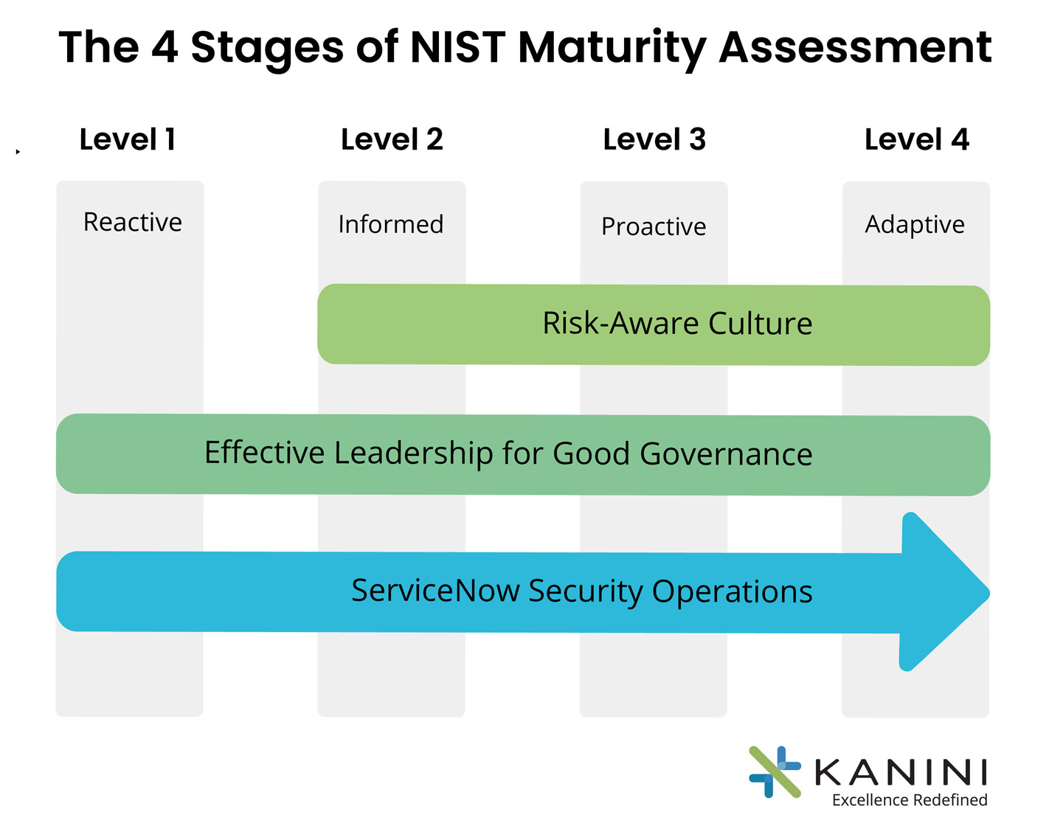

Figure 2.2 – NIST CSF Maturity Levels

— Level 1 - Partial: Level 1 organizations have limited knowledge of cybersecurity risks and do not have formal processes to address them. They have an ad hoc approach to cybersecurity and often react to incidents on a case-by-case basis. Cyber security activities are not well defined or coordinated within the organization.

— Level 2 - Informed of Risks: Level 2 organizations have a basic understanding of their cybersecurity risks and have begun to implement some risk management processes. They have begun to develop a formalized cybersecurity program, but it may not be fully integrated into the organization's overall risk management processes.

— Level 3 - Repeatable: Level 3 organizations have a structured and repeatable cybersecurity program in place. They have documented processes and procedures in place that they regularly update and improve. They have a good understanding of cybersecurity risks and have implemented risk mitigation strategies. Cyber security activities are regularly monitored and reviewed for their effectiveness.

— Level 4 - Adaptation: Level 4 organizations have a mature and adaptable cybersecurity program that is continuously monitored, evaluated, and improved. They have a deep understanding of cybersecurity risks and proactively adapt their strategies and practices to address emerging risks. The culture of cybersecurity is well established throughout the organization and cybersecurity is integrated into all aspects of business processes.

## Roles:

— Identify: The "Identify" function consists of understanding and managing cybersecurity risks in a comprehensive manner. This includes identifying and inventorying assets, assessing vulnerabilities, determining potential impacts, and establishing governance processes to effectively manage cybersecurity within the organization.

— Protect: The "Protect" function is mainly focused on the implementation of protective measures against cybersecurity threats. It involves developing and implementing policies, procedures and controls to ensure the confidentiality, integrity and availability of systems, assets and data reviews.

— Detect: The "Detect" function focuses on building capabilities to quickly identify cybersecurity incidents. It involves putting in place monitoring systems and processes to detect and analyze anomalous activity, indicators of compromise, or unauthorized access. The goal is to enable a quick reaction and mitigate damage or potential malfunctions.

— Respond: The "Respond" function involves the development and implementation of effective response strategies to deal with detected cybersecurity incidents. This includes establishing an incident response plan, defining roles and responsibilities, coordinating communication and collaboration, and executing appropriate actions to contain and mitigate the impact of incidents.

— Recover: The "Recovery" function is focused on developing and implementing plans and processes to restore capabilities or services that have been affected by cybersecurity incidents. It is about carrying out the right activities to restore data, systems and functionalities. It also involves conducting post-incident analysis, assessing lessons learned, and updating plans to improve resilience and prevent future incidents.

## The Access Control (AC) family:

Access control encompasses a sophisticated set of mechanisms, policies, and procedures that allow organizations to establish and enforce appropriate limits and restrictions regarding who can access specific resources, when access is allowed, and what actions can be taken once access is granted. It aims to prevent unauthorized access, preserve the confidentiality and integrity of sensitive information, and ensure that only authorized individuals or entities can interact with critical systems and data.

|  |  |  |
| --- | --- | --- |
| Access Control (AC) | | |
| AC-2 : Account Management | | |
| This control covers activities such as creating user accounts, maintaining them throughout their lifecycle, and deactivating accounts when they are no longer necessary. | | |
| AC-2(1) | Automated account management | Support system account management using automated mechanisms defined by the organization. |

|  |  |  |
| --- | --- | --- |
| AC-2(3) | Deactivate accounts | Deactivate accounts within a time frame set by the organization when accounts:  (a) have expired;  (b) are no longer associated with a user or person; (c) are in violation of the organization's policy; or(d) have been inactive for a period defined by the organization. |
| AC-2(4) | Automated audit actions | Automatically audit the actions of creating, editing, enabling, deactivating, and deleting accounts. |
| AC-2(7) | Privileged user accounts | Establish and manage privileged user accounts in accordance with a role-based access system and an attribute-based access system; (b) Control the assignment of privileged roles or attributes. (c) monitor changes to roles or attributes; and(d) revoke access when assigning privileged roles or attributes is no longer appropriate |
| AC-2(8) | Dynamic Account Management | Dynamically create, enable, manage, and deactivate organization-defined system accounts |
| AC-3: Enforcement of access controls | | |
| This control aims to strengthen the implementation and enforcement of access controls. This is to make access controls more robust and effective by implementing measures such as stronger authentication methods, stricter authorization rules, regular access controls, and monitoring of unauthorized usage | | |

|  |  |  |
| --- | --- | --- |
| AC-3(2) | Dual authorization | Apply Dual Authorization for Privileged Orders and Actions defined by the organization. |
| AC-3(3) | Proxy access control | Proxy access control policies limit the actions that subjects can take with respect to privilege propagation, i.e., a subject with a privilege cannot pass that privilege to other subjects. |
| AC-3(4) | Discretionary access control | Subjects are not limited in the actions they can take with the privileges they have already had access to. Thus, subjects who have been granted access to privileges are not prevented from transmitting these privileges to other subjects |
| AC-3(7) | Role-based access control (RBAC) | Apply a role-based access control policy to defined topics and objects, and control access based on organization-defined roles and users who are authorized to assume those roles. |
| AC-3(8) | Revocation of Authorizations  Access | Enforce revocation of access permissions resulting from changes to subject and object attributes based on organization-defined rules. |
| AC-3(13) | Attribute Based Access Control (ABAC) | Apply an attribute-based access control policy to defined subjects and objects, and control access based on attributes defined by the organization to assume access permissions. |

|  |  |  |
| --- | --- | --- |
| AC-3(15) | Discretionary and Proxy Access Control | Apply the mandatory access control policy defined by the organization to all topics and objects covered specified in the policy; and (b) Apply the organization's discretionary access control policy to all covered topics and objects specified in the policy. |
| AC-4 : Information flow control | | |
| This control focuses on the implementation and enforcement of measures to control the flow of information within an organization's systems and networks, in order to prevent unauthorized or unintentional flows of information. | | |
| AC-4(9) | Human Review | Strengthen the use of human journals under the conditions defined by the organization. |
| AC-5 : Segregation of duties | | |
| The goal of this control is to ensure that no one person controls or has access to critical functions or sensitive information within an organization. by assigning different responsibilities to different people. | | |
| * Identify and document the functions defined by the organization that need to be separated. * Define system access permissions to support segregation of duties. | | |
| AC-6 : Minimum Privilege | | |
| This control focuses on the principle of granting users the minimum level of privileges necessary to perform their duties. | | |
| AC-6(5) | Privileged accounts | Restrict privileged accounts on the system to people or organization-defined roles. |
| AC-6(7) | User Privilege Review | Review the privileges assigned to organization-defined user roles or categories to validate the need for those privileges. and (b) reassign or remove privileges, as necessary, to accurately reflect the organization's mission and operational needs. |

The NIST CSF controls depicted in the tale support Zero Trust principles by promoting granular access control, minimizing privileges, and enforcing robust account management. "Automated account management" and "Deactivate accounts" contribute to Zero Trust by automating the lifecycle of user accounts, minimizing manual errors, and ensuring accounts are promptly deactivated when no longer needed.

"Segregation of Duties" and "Minimum Privilege" embody the core of Zero Trust, advocating for the principle of least privilege by ensuring users only have access to the resources needed for their specific tasks.

"Privileged accounts" and "User Privilege Review" further reinforce Zero Trust principles by restricting privileged access and implementing regular reviews to ensure these accounts are appropriately assigned and used. These controls, when implemented effectively, promote a continuous verification of user access, minimizing the blast radius of potential breaches, and ensuring only authorized access to critical resources.

By adopting these practices, organizations can move towards a more secure and resilient posture where trust is never assumed, and access is granted based on stringent verification and authorization policies.

## Benchmark

Using the previous study of cybersecurity standards, we produced 10 criteria that are going to help us determine the best solution for our Policy Decision Point. These criteria are also based on Zero Trust principles and IAM security requirements. First, we are going to compare 2 proprietary software solutions (PlainID, Axiomatics), then we will compare 2 open-source solutions.

|  |  |  |
| --- | --- | --- |
| **Criteria** | **PlainID** | **Axiomatics** |
| **Role-Based Access Control (RBAC):** Evaluate the solution's ability to define and enforce granular user role-based authorization policies that allow for fine-grained control over access to resources. | Uses PBAC (Policy-Based Access Control) | Uses PBAC (Policy-Based Access Control) |
| **Attribute-Based Granularity (ABAC):** Evaluate the solution's ability to define and enforce granular authorization policies based on device attributes and context that allow for fine-grained control over access to resources. | Uses PBAC (Policy-Based Access Control) | Uses PBAC (Policy-Based Access Control) |
| **Flexibility and Management of Access Policies:** Examine the flexibility of the solution in the definition and management of access policies, allowing adaptation (Fine grain, Medium grain, Coarse grain) to the specific needs of the organization and the different applications and resources. | Flexible, can operate in Coarse grain and Fine grain | Flexible, can operate in Coarse grain and Fine grain |
| **Multi-Factor Authentication (MFA):** The ability to call external MFA systems. | Can be integrated with PingFederate connected to PingONE MFA | Uses custom fetch providers to retrieve the status of a custom service |
| **Real-time Monitoring and Access Behavior Analytics:** Ability to monitor and analyze access behaviors to detect anomalies and suspicious activity and connect to monitoring and detection solutions. | Ability to gain insights across identities with operational reports and suggestions, and integration with SIEM and logging tools via APIs | OPAL Client Tracker (EAP) to track connected OPAL clients, Crowdstrike for user behavior, SIEM such as Splunk, Tableau, Elasticsearch |
| **Secure Integration with Identity Sources:** Seamless integration with existing identity sources such as corporate directories and directories. | Can be integrated with identity sources like Okta, PingFederate, Forgerock, AD with a direct connection | Prend en charge diverses sources de données externes : Kafka, Okta, LDAP, HTTP, Git et S3 |
| **Secure Cloud Services Integration:** Seamless integration with cloud services to manage access to cloud-hosted applications and data. | Access to AWS resources is now controlled from interaction with IdentityIQ, no direct sign-in for Azure | Uses custom fetch providers to retrieve the status of a custom service |
| **Visibility and Auditability:** Analyze the solution's tracking, logging, and reporting capabilities to provide complete visibility into the application, enabling effective auditing and compliance with regulatory and internal requirements. | Audit report option included, and logging option included | Logging option included and OPAL Statistics |
| **Identity and Privileged Access Management (PAM):** Ability to integrate external PAM systems. | Can be achieved through Saviynt PAM using an API | Uses custom fetch providers to retrieve the status of a custom service |
| **Identity Governance and Administration (IGA):** The ability to integrate with IGA systems. | Supports integration with IGA systems like SailPoint using a direct connection, for Saviynt you will need an API | Uses custom fetch providers to retrieve the status of a custom service |

Based on this comparison we can conclude that PlainID would be a better solution to use based on the number of features and functionalities, the complexity of implementation and scaling and the criteria for a Zero Trust architecture.

Now let’s compare OPA+OPAL and Cerbos for the open-source solutions.

|  |  |  |
| --- | --- | --- |
| **Criteria** | **OPA+OPAL** | **Cerbos** |
| **Role-Based Access Control (RBAC):** Evaluate the solution's ability to define and enforce granular user role-based authorization policies that allow for fine-grained control over access to resources. | Does not support RBAC | Supports RBAC |
| **Attribute-Based Granularity (ABAC):** Evaluate the solution's ability to define and enforce granular authorization policies based on device attributes and context that allow for fine-grained control over access to resources. | Uses ABAC to control access to data and applications | Supports ABAC |
| **Flexibility and Management of Access Policies:** Examine the flexibility of the solution in the definition and management of access policies, allowing adaptation (Fine grain, Medium grain, Coarse grain) to the specific needs of the organization and the different applications and resources. | Works in Fine grained Access Control | Works in Fine grained Access Control |
| **Multi-Factor Authentication (MFA):** The ability to call external MFA systems. | Can integrate with external MFA systems like Okta Adaptive MFA | Can integrate with external MFA systems via APIs |
| **Real-time Monitoring and Access Behavior Analytics:** Ability to monitor and analyze access behaviors to detect anomalies and suspicious activity and connect to monitoring and detection solutions. | Integration with SIEM is possible | Records logs and can connect to external SIEM system via APIs |
| **Secure Integration with Identity Sources:** Seamless integration with existing identity sources such as corporate directories and directories. | Can use external APIs, offers standard attribute connectors, and can connect to existing IdPs | Can be integrated with IdPs such as Okta, Keycloak, FusionAuth, AWS Cognito via APIs |
| **Secure Cloud Services Integration:** Seamless integration with cloud services to manage access to cloud-hosted applications and data. | Can be integrated with cloud services such as Avassa, Jenkins, Red Hat Openshift, AWS, Docker, Google Cloud, Open Policy Agent, Azure, Kubernetes | Can be integrated with cloud services such as Docker, Kubernetes, Google Cloud, Azure Kubernetes Service, AWS Lambda, Amazon EKS |
| **Visibility and Auditability:** Analyze the solution's tracking, logging, and reporting capabilities to provide complete visibility into the application, enabling effective auditing and compliance with regulatory and internal requirements. | Logs can be stored | Logs can be stored |
| **Identity and Privileged Access Management (PAM):** Ability to integrate external PAM systems. | Can integrate with multiple PAM solutions such as SailPoint IdentityIQ, Saviynt Enterprise Identity Cloud | Can integrate with multiple PAM solutions such as Okta Privileged Access via APIs |
| **Identity Governance and Administration (IGA):** The ability to integrate with IGA systems. | Can integrate with multiple identity governance providers such as SailPoint, Saviynt, One Identity | Can integrate with multiple identity governance providers such as Okta Identity Governance via APIs |

Based on this table we can conclude that Cerbos is a better fit for our demonstrator, it fits most of the criteria perfectly, it is open source and less complex when it come to implementation, usability and connection to other applications.

## Plan (Gant diagram)

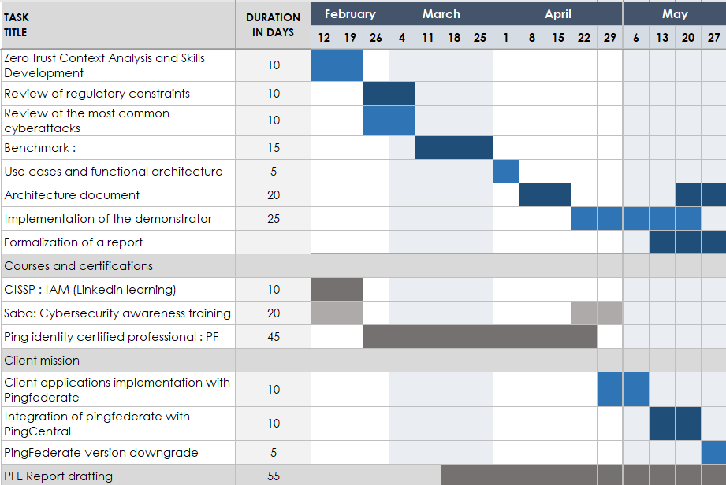

# Chapter 3: State of the art

## Zero Trust and Identity and Access Management

## Zero Trust

## History

The concept of Zero Trust emerged as a response to the evolving threat landscape and the limitations of traditional perimeter-based security models. The traditional approach relied on the assumption that anything inside the network perimeter was trusted, while anything outside was considered untrusted. However, with the rise of remote work, mobile devices, cloud computing, and sophisticated cyberattacks, the perimeter became increasingly porous and less effective.

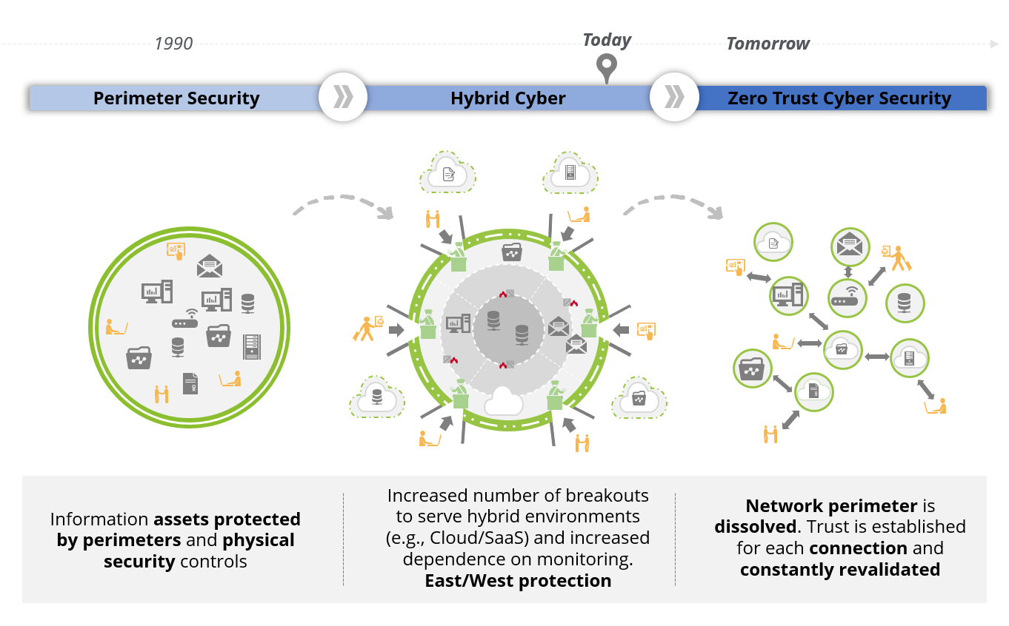

The Zero Trust model was first conceptualized in the early 2000s by John Kindervag, a security analyst at Forrester Research, who coined the term "Zero Trust Network Access" (ZTNA). Kindervag argued that organizations should assume no user or device is inherently trustworthy and that all access requests should be strictly verified and authorized based on the principle of least privilege.

## Definition and Concept of Zero Trust

Zero Trust is a security framework that emphasizes the continuous verification of all access requests and the assumption that no user or device should be trusted implicitly. It shifts the security paradigm from perimeter-based to identity-centric, focusing on verifying the identity of every user and device before granting access to resources.

The fundamental principle of Zero Trust is to "**never trust, always verify**" This means that organizations must treat every access request as potentially malicious and implement rigorous security measures to validate the identity and authorization of users and devices before allowing access to sensitive data and systems.

## Principles and Advantages of Zero Trust

The Zero Trust framework is built on several core principles that aim to enhance security and resilience:

**Continuous Verification**: All access requests, regardless of origin or source, must be continuously validated and authenticated.

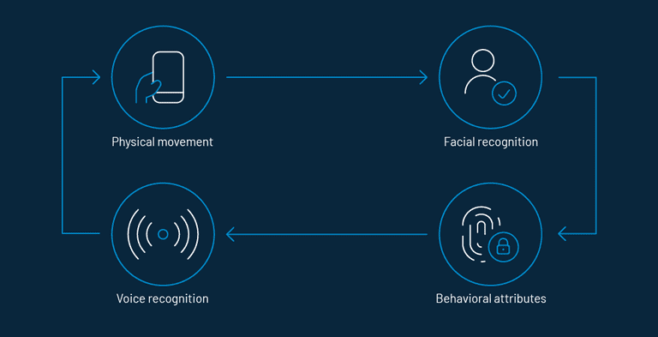Continuous authentication

**Least Privilege**: Users should only be granted access to the resources they need to perform their job functions.

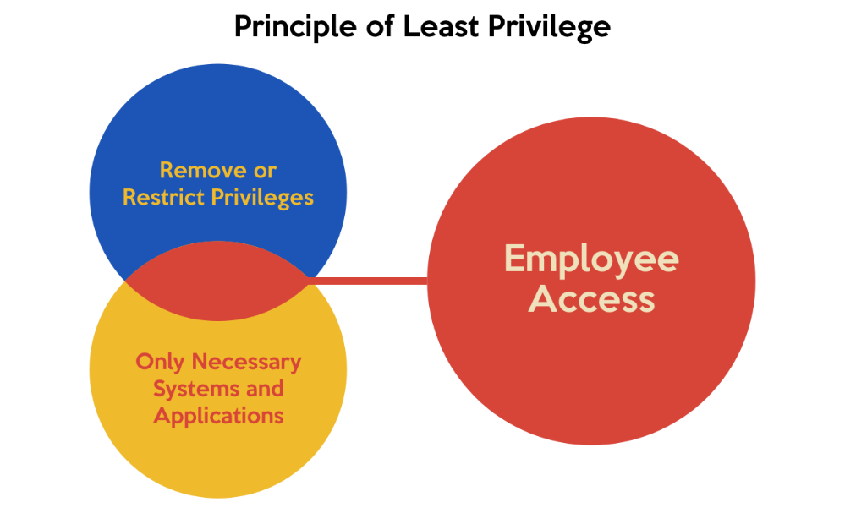

Principle of least privilege

Access to resources outside of their scope should be restricted.

**Micro-segmentation**: Networks and applications should be segmented into smaller, isolated units to limit the impact of breaches.

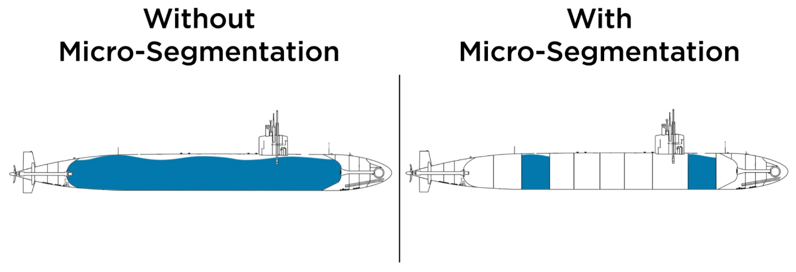

This figure shows the importance of micro segmentation in cybersecurity, it prevents attacks from spreading from the infected part of the network to the remaining parts. With no no segmentation, the network is an open floor for the attacker.

**Data-Centric Security**: Data protection is prioritized, and access controls are implemented based on the sensitivity of the data being accessed.

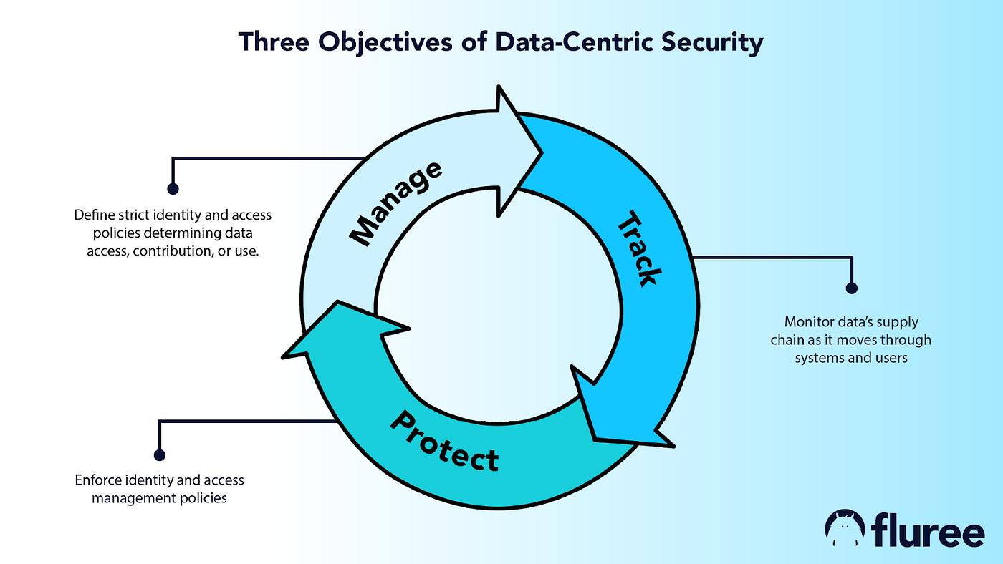

Not all data is the same, most organizations have different types of data, from sensitive to critical data. Each type has different levels of protection and access restrictions.

**Multi-Factor Authentication (MFA)**: MFA is mandatory for all access requests to ensure strong authentication and minimize the risk of unauthorized access. It is about using more than one authentication method, it can **something you know** (password), **something you have** (token, one-time-passcode) or **something you are** (fingerprint, face ID).

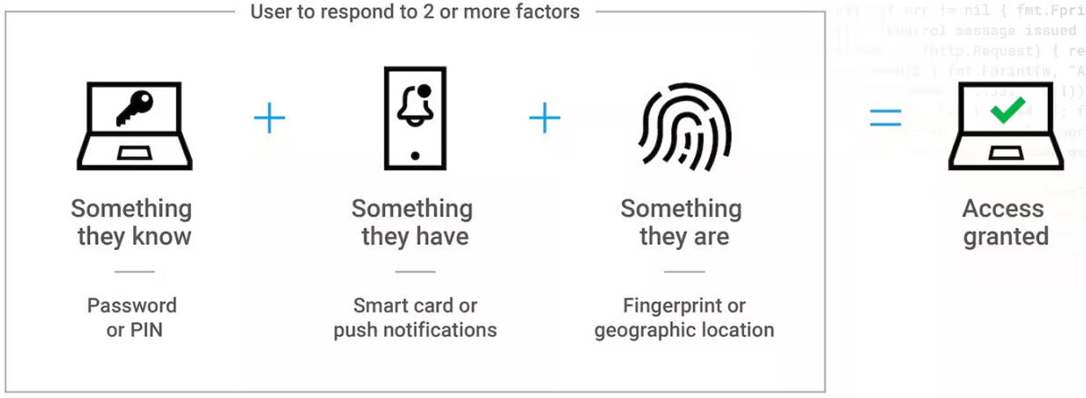

The advantages of adopting a Zero Trust approach include:

**Enhanced Security**: By assuming no trust, organizations can better mitigate the risk of insider threats, data breaches, and other security incidents.

**Improved Resilience**: Zero Trust helps organizations recover more quickly from security incidents by limiting the impact of a compromise to a specific segment or resource.

**Increased Flexibility**: The Zero Trust framework is highly adaptable and can be implemented in various environments, including on-premises, cloud, and hybrid infrastructures.

**Improved Compliance**: Zero Trust principles align with regulatory requirements, such as GDPR and PCI DSS, by helping organizations demonstrate compliance with data privacy and security standards.

## Key Components of Zero Trust

The Zero Trust framework typically includes several key components:

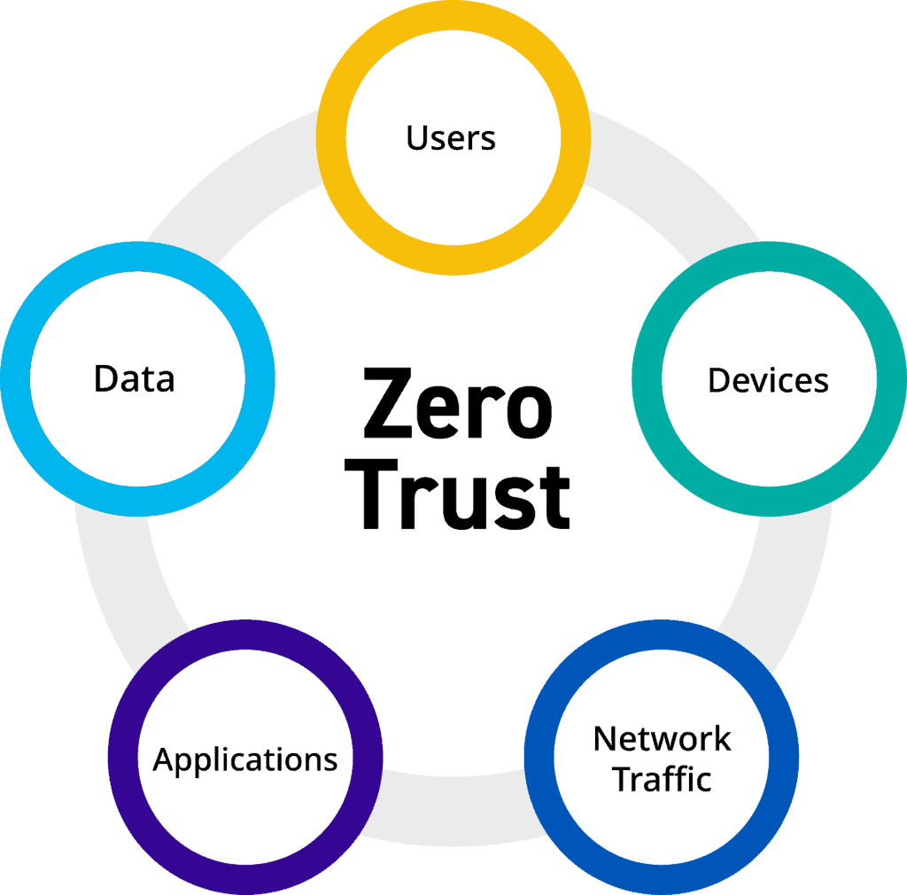

**-Users/Identities:** this component concerns every aspect of the user’s identity including,

* Identity governance and administration
* Advanced, risk-based authentication
* Multi-factor authentication
* Dynamic authorization
* Privileged access management

**Applications/Workloads:** this concerns the applications running in the organization,

* Application security
* Secure design / architecture
* Secure development and testing
* Secure configuration and change management
* Vulnerability management
* Container security

**Data:** involves data handling**,**

* Data discovery, inventory, and catalog
* Data classification
* Data access governance
* Certificate and key management
* Encryption and obfuscation
* Data loss prevention
* Data retention and destruction

**Network:** This concerns the physical network of the organization,

* Network standards
* Network architecture
* Network access control
* Zero Trust Network Access (ZTNA)
* Network / micro segmentation
* Policy / rule recertification
* Cloud access security broker

**Devices:** Includes the organization’s devices,

* Configuration, patch, and vulnerability management
* IT asset management
* Internet of things (IOT) security
* Operational technology (OT)
* Managed / unmanaged device security

## Zero Trust Architecture according to NIST

The National Institute of Standards and Technology (NIST) has published the Cybersecurity Framework (CSF), which provides guidance for implementing Zero Trust architectures. NIST’s Zero Trust framework emphasizes the following key elements:

**Identity Management**: Establishing a secure identity foundation, including the use of multi-factor authentication and strong password policies.

**Device Access Control**: Restricting access based on device type, configuration, and security posture.

**Network Access Control**: Enforcing network segmentation and implementing micro-segmentation policies to limit lateral movement of attackers.

**Application Access Control**: Implementing granular access controls for applications and data based on user roles and privileges.

**Data Protection**: Implementing measures to protect sensitive data at rest and in transit, including encryption and data loss prevention.

**Security Monitoring and Analytics**: Continuously monitoring network traffic, user activity, and security events to detect and respond to threats.

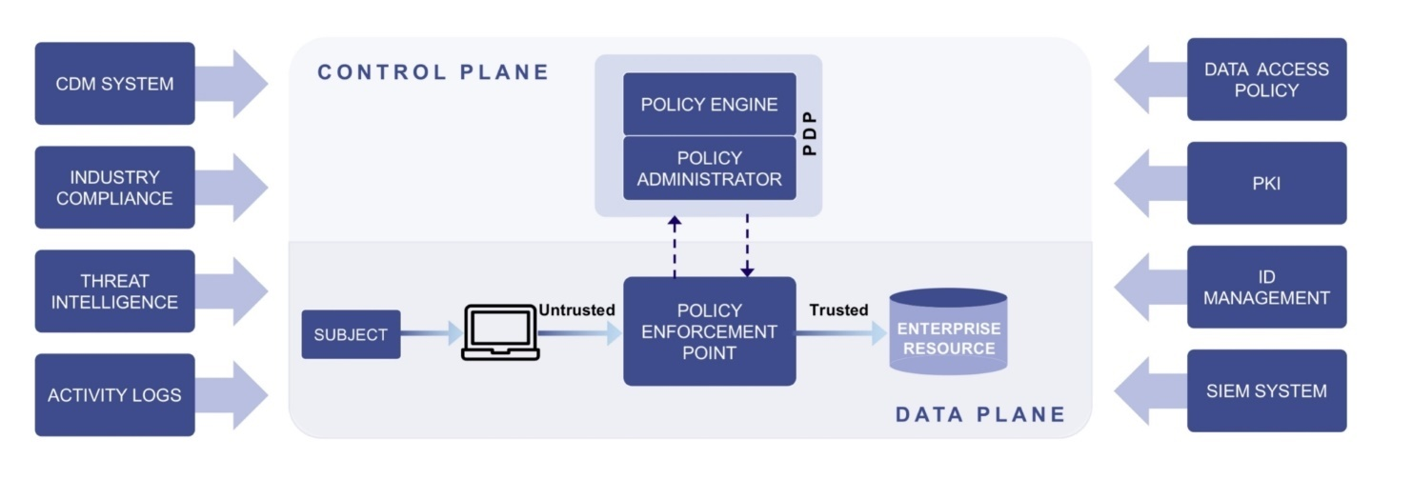

NIST Zero Trust architecture

## Limitations of Zero Trust

While Zero Trust offers significant security advantages, it also has some limitations, for example, its **complexity**. Implementing a comprehensive Zero Trust framework can be complex and require significant investment in technology and resources. It requires organization years to achieve a full Zero Trust architecture. **Performance overhead** is another issue, the continuous verification and authorization processes can introduce performance overhead, particularly in high-traffic environments. It also worsens the **user experience** as strict access controls and multi-factor authentication may negatively impact user experience and productivity. **False Positives** also become an issue, Zero Trust systems may generate false positives, leading to unnecessary security alerts and potentially disrupting operations.

## Identity and Access Management

## Concepts of IAM

Identity and Access Management (IAM) is a fundamental security concept that focuses on managing user identities and controlling access to sensitive data and systems. IAM ensures that only authorized users have access to the resources they need to perform their job functions, while preventing unauthorized access and protecting sensitive data from unauthorized disclosure.

IAM is a comprehensive and multifaceted approach to security, encompassing several key elements, such as:

* **Identity Management**: Managing user identities, including creation, verification, authentication, and authorization.
* **Access Control**: Defining and enforcing rules and policies for accessing data and systems based on user roles and permissions.
* **Password Management**: Implementing strong password policies and secure password storage solutions to prevent unauthorized access.
* **User Provisioning and De-provisioning**: Automating the process of granting and revoking user access based on changes in job roles and responsibilities.
* **Auditing and Monitoring**: Tracking user activity and access attempts to identify potential security threats and ensure compliance with security policies.

## Digital Identities

A digital identity represents a user's online presence and is used to authenticate and authorize access to digital resources. It typically includes:

Username: A unique identifier used to log into a system or account.

Password: A secret code that verifies the user's identity and authorizes access.

Attributes: Additional information about the user, such as name, email address, phone number, or job title.

Digital identities are used to verify user authenticity, control access to sensitive data and systems, and track user activity for auditing and compliance purposes.

## Components of IAM

A comprehensive IAM system consists of various elements working together to manage user identities and access rights. Key elements include:

Identity Store: A central repository that stores user identities and attributes.

Authentication Mechanisms: Processes used to verify user identities, such as password-based authentication, multi-factor authentication, biometrics, and token-based authentication.

Authorization Engine: A component that evaluates user permissions and decides whether a user is authorized to access a specific resource.

Access Control Policies: Rules and guidelines that define access privileges for different users and groups.

User Interface (UI): A user-friendly interface that allows users to manage their own identities and access settings.

Administrative Tools: Tools for IAM administrators to manage user accounts, configure access policies, and monitor security events.

## Identity Lifecycle

The identity lifecycle encompasses all stages of an identity’s existence, from creation to deactivation. It typically includes:

Identity Creation: Creating new user accounts and assigning initial permissions and roles.

Authentication: Verifying the identity of users attempting to access systems or resources.

Authorization: Granting or denying access based on user roles, permissions, and policies.

Access Management: Managing user access rights, granting or revoking permissions, and enforcing access control policies.

Identity Deactivation: Removing user access and deleting account information when an individual leaves the organization or their role changes.

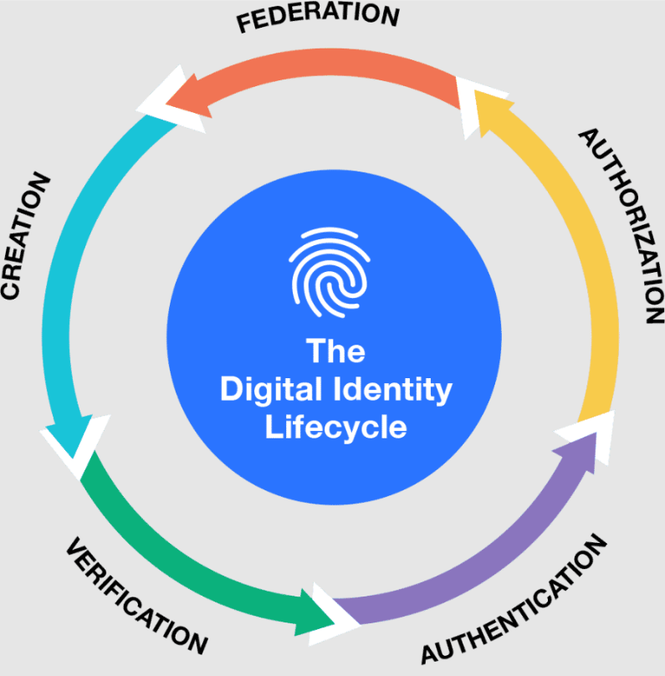

## Access Management

Access management is a critical component of IAM, encompassing the processes of defining, granting, and revoking access to resources based on user roles and privileges. Effective access management ensures that users only have access to the resources they need to perform their job functions, minimizing the risk of unauthorized access and data breaches.

Key aspects of access management include:

Access Control Lists (ACLs): Lists of users and their associated permissions for accessing specific resources.

Role-Based Access Control (RBAC): Assigning roles to users and associating specific permissions with those roles, simplifying access management and streamlining policy enforcement.

Attribute-Based Access Control (ABAC): A more sophisticated form of access control that uses attributes, such as user location, device type, and network context, to make access decisions.

Access Reviews: Regularly reviewing user access rights to ensure they remain aligned with current job responsibilities and security policies.

## Identity Governance and Administration (IGA)

Identity Governance and Administration (IGA) is a comprehensive approach to managing user identities and access rights throughout the entire lifecycle. IGA combines best practices from IAM, security, compliance, and risk management to ensure that identities are properly managed and that access to sensitive information is appropriately controlled.

IGA includes the following key principles:

Centralized Identity Management: Consolidating identity management processes and data into a single system to streamline operations and improve efficiency.

Automated Provisioning and De-provisioning: Automating the process of creating and deleting user accounts and assigning or revoking access based on predefined rules and policies.

Access Certification: Regularly reviewing user access rights to ensure they are appropriate and aligned with current job responsibilities.

Identity Lifecycle Management: Managing the entire lifecycle of user identities, from creation to deactivation.

Compliance and Audit: Ensuring that identity management processes meet compliance requirements and documenting user activity for audit purposes.

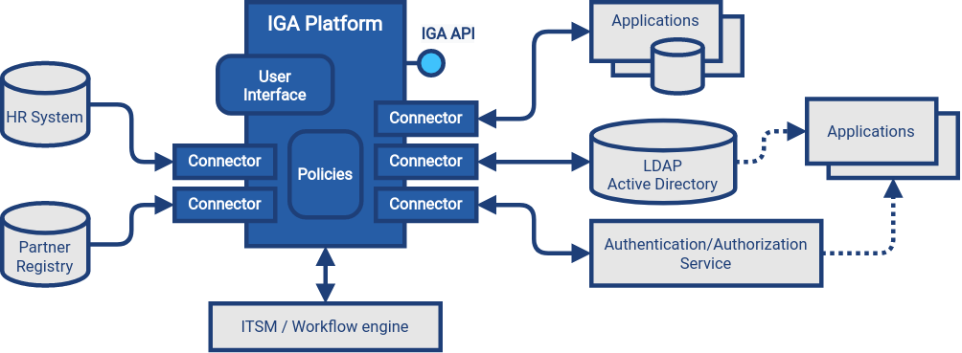

IGA Architecture

## Governance, Risk, and Compliance, and Separation of Duties

Effective identity management must consider governance, risk, and compliance (GRC) principles to ensure that access is granted appropriately, and that sensitive data is protected from unauthorized access.

Governance: Establishing clear policies and procedures for managing user identities and access rights, including roles, responsibilities, and approval processes.

Risk Management: Identifying and assessing risks associated with identity management, such as unauthorized access, data breaches, and identity theft, and implementing appropriate controls to mitigate those risks.

Compliance: Ensuring that identity management practices comply with relevant regulatory requirements, such as GDPR, HIPAA, and PCI DSS, to protect sensitive data and ensure compliance with legal and ethical standards.

Separation of Duties: Dividing responsibilities for managing user identities and access rights to prevent any single individual from having too much control over the system. This principle helps minimize the risk of unauthorized access or malicious activity.

By implementing sound governance, risk management, compliance, and separation of duties practices, organizations can enhance the security and integrity of their identity management systems, promoting secure and reliable access to sensitive information.

# Chapter 4: – Comparative study and presentation of solutions

Chapter 4: Project study

## Solutions used in our project

In this section, we will present each solution used in our demonstrator, explain how they work, and detail their technical specifications.

By presenting each solution in this way, we will provide a clear understanding of the architecture and technologies used in our demonstrator, as well as a solid foundation for performance evaluation.

## Functional architecture

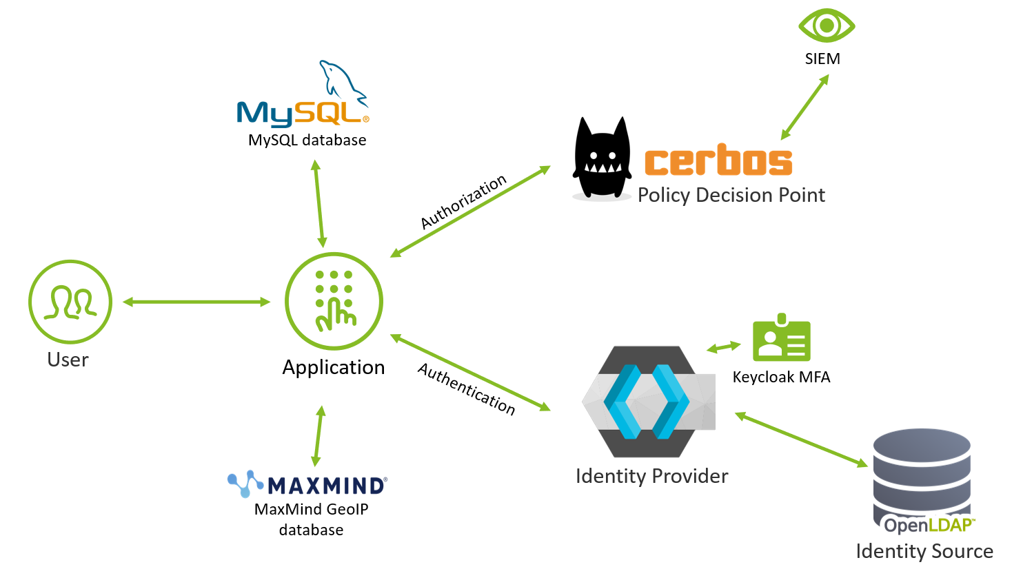

**Application**: is what the user interacts with, it is connected to the MySQL database to retrieve the transaction resources, it also connects to both Keycloak and Cerbos for authentication and authorization respectively, and finally it uses the Maxmind database to get the user location based on his public IP address.

**Keycloak:** is called by the application to authenticate users, it is connected to the OpenLDAP directory which is the identity source where all the users’ identities are stored, also serves as an MFA for our application.

**Cerbos:** After the user is authenticated using Keycloak, the user information is sent to Cerbos in the form of user attributes and the Cerbos PDP makes the decision on whether the user is allowed or denied access based on their credentials and roles.

**MySQL:** Is the database linked to our application, it stores the transactions and resources the users are trying to access.

**OpenLDAP:** Is the directory used to store all user identities that serve to authenticate users with the help of Keycloak.

**Maxmind:** Is the database that contains all IP addresses linked to their respective locations, which helps our app determine the location of the user and use it as one of the attributes.

## Cerbos

## What is Cerbos

Cerbos is the authorizer and Policy Decision Point (PDP) we are using for our architecture, it’s the point where the decision to allow or deny access to our resources is made. Cerbos is a solution to make authorization simpler to implement and manage, thus freeing up product teams to focus their efforts on building their core product and drive business value.

Authorization is a critical aspect of any software product, and it is essential to get it right. However, the process of implementing, maintaining, and scaling access control logic is time-consuming, complicated, and messy.

That's where Cerbos comes in. Cerbos makes fine-grained access control easy to implement and manage while saving months of developer time:

• Improves security by making access control highly visible and making it easy to keep up with changing requirements.

• Provides flexible tooling for authoring, testing, and deploying access policies, and seamlessly integrates into any architecture.

• Decouples authorization from application silos and makes it reusable by all your software code written in any language, and seamlessly scales from prototype to global deployment.

## How does it work

Cerbos enables authorization logic to be written as policy outside of your application code, replacing the complex checks with a simple call out to a Cerbos which returns an ALLOW or DENY based on the data in the context provided and the current live policies.

Policies are defined as human readable YAML and are stored either on disk, Cloud Storage, a GitHub repository, or a database. Policies define the resources in the system, what actions can be taken upon them. Based on information about the principal/user making the request and what resource is being accessed conditions can be defined which are computed on the fly for fine-grained access control.

As the policy is now abstracted outside of the application logic, business requirements can change, and policies updated without having to make any code changes or releases.

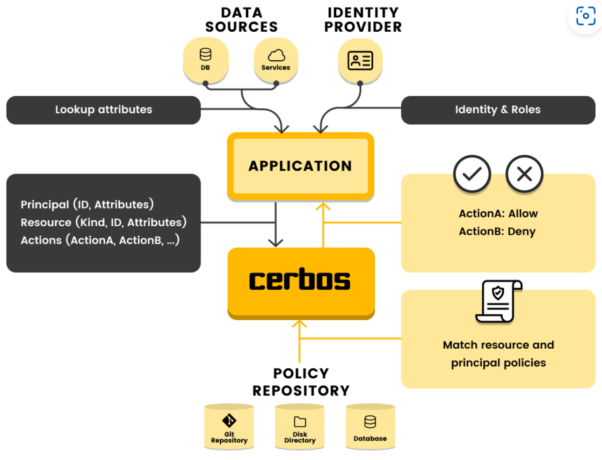

Where complicated permission logic would have been done previously, it is replaced with a call out to check the permissions against a deployed Cerbos instance. This call requires 3 bits of information:

**Principal** - who is making the request.

**Resource** - what are they trying to access.

**Action(s)** - what are they trying to do to the resource.

Here is a more detailed diagram explaining the flow of a request in Cerbos:

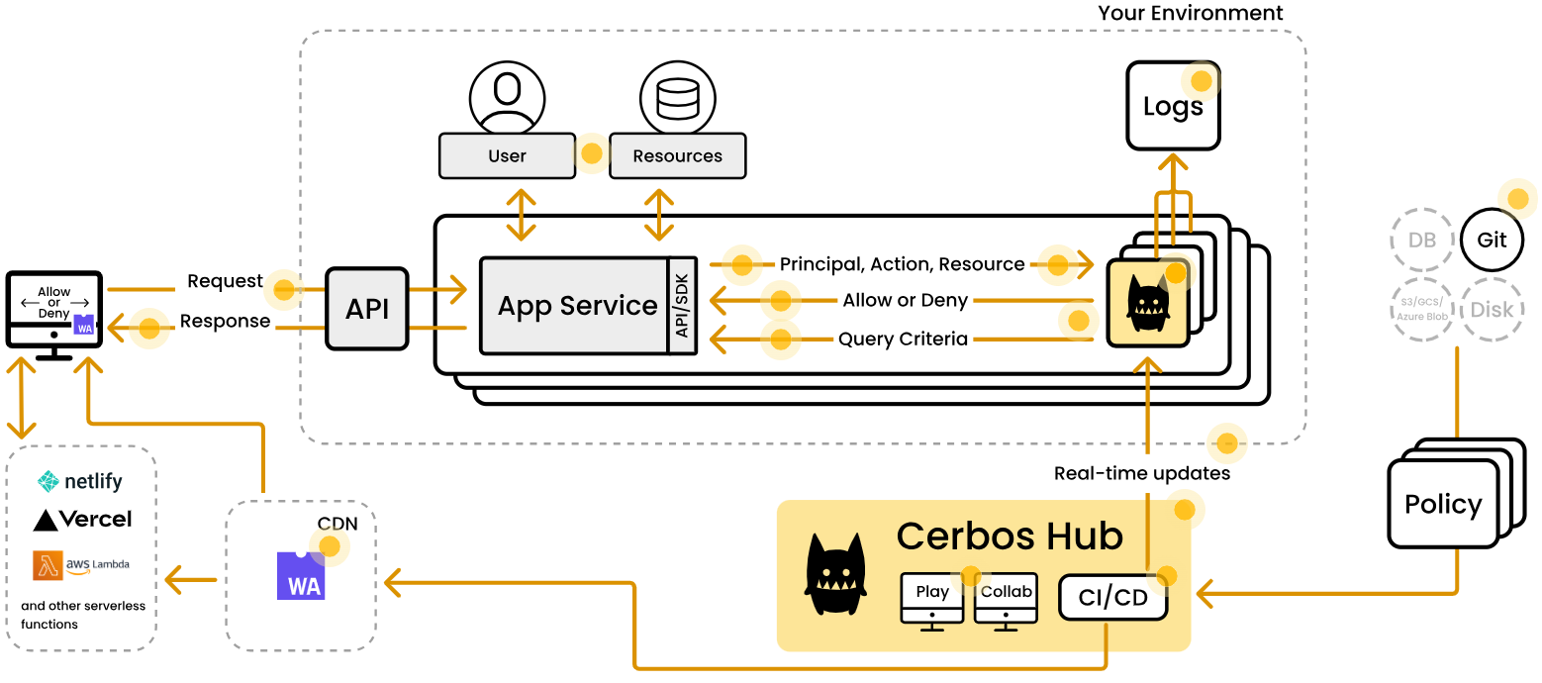

**-Request**: When a user performs an action, the first thing that would happen in the application layer is the unbundling of that request to understand who is trying to perform what action; and on which resource or object.

**-Users & Resources:** The application layer then further unbundles these two data points:

User’s identity: The identity or the principal (could be a user or a service account) can be looked up in the IdP (Identity Provider) or app database to fetch further attributes such as groups the user is a part of; or the departments and/or geographies it belongs to.

The resource that is being accessed or mutated: What state that object is in, and any additional information about its attributes.

**-Principal, action, resource:** In order to make a decision on whether an action should be allowed; traditionally one would implement an if-then-else block based on the principal and resource attributes.

Cerbos decouples and centralizes the logic out of the application code. All of the information about the principal, action and the resource gets submitted via Cerbos SDK to its API.

The SDK interacts with the Cerbos instance that would be running within your environment via the REST API or gRPC. Cerbos makes a decision whether that action should be allowed or not. See point 4 for more details about the request.

**-Cerbos:** Cerbos can run as a binary on bare metal machine or VM; or you can deploy Cerbos’s container in your environment. You can even run Cerbos on serverless infrastructure like AWS Lambda, Google Cloud Functions or Google Cloud Run. If Cerbos is deployed to a container orchestrator like Kubernetes, it can be run either as a service or as a sidecar.

Cerbos is a stateless decision engine that will make decisions based on the incoming request and the provided policies. No matter which storage method you choose, you can always use the Cerbos’s unit testing framework and policy validation tools before making changes to your environments.

Once policies are loaded, the Cerbos instance is ready to process incoming requests via its REST and gRPC APIs, and log both the requests it receives and decisions it makes.

**-Cerbos hub:** Cerbos Hub is managed control plane for Cerbos. A scalable solution for developers who want to save time, streamline their workflows and confidently author and roll out authorization updates.

When a Cerbos instance starts, after reading its configuration file, it connects to Cerbos Hub via an encrypted channel to receive its policies. The policies are loaded to the Cerbos Policy Decision Points, PDPs' memory. From that moment on, whenever there is a successful and fully tested update to the policies Cerbos Hub distributes precompile policies to the relevant instances of PDPs.

The access rules for each resource and action are stored in the policies. In addition to the resource policies, these policies can also include derived role definitions, individual principal policies, and request attribute requirements.

Cerbos PDPs do not have to reload or look up the policies every time it gets a new request. However, whenever Cerbos Hub transfers a new policy, they hot-reload the latest policy.

**-Cerbos playground:** Cerbos Hub also provides a playground to help users to collaboratively author, change and tested policies before committing them.

**-CI/CD:** Every time Cerbos Hub detects a new commit in the Git repository, it kicks off a CI/CD pipeline. The policies are first validated and then compiled and tested against the test cases. If the tests pass, the policies are then distributed to the PDPs that are connected and subscribed to specific distribution tag.

If any of the tests fail, Cerbos Hub will not distribute the policies to the PDPs and will highlight the issues for the users to fix.

**-Logs:** Every decision that Cerbos makes get logged with the full details of the request, decision and why/how that decision was made: which policy it matched etc.

**-Git:** Users configure Cerbos Hub to connect to a Git repository where they store the policy files. The policy files are hosted and owned by the users. Cerbos Hub does not store the policy files. Cerbos Hub only stores the compiled policies that are encrypted with the workspaces' encryption key.

Every time there is an update to the policy, Cerbos automatically detects the change and kicks off a CI/CD pipeline.

**CDN:** Cerbos Hub also produces a Web Assembly module that can be used to make authorization decisions at the edge. This module is a lightweight, secure, and portable way to run Cerbos in any environment. It is built by Cerbos Hub and hosted on a reliable CDN. Each one of the build tags/environments will have its own URL that can be used to fetch the module.

## Cerbos features

**-Policy-Based Access Control (PBAC)** is a dynamic approach to manage access control in complex environments. It utilizes a policy engine and a policy definition language (Cerbos uses simple YAML) to articulate and enforce access rules. In PBAC, policies define the criteria for access and are managed using standard software development lifecycle tools, offering a scalable and adaptable solution for varying access control needs.

* Flexibility and scalability: Adapt to changing access needs with ease.
* Granular control: Define access based on multiple conditions and contexts.
* Integration with development tools: Manage policies using familiar software development practices.

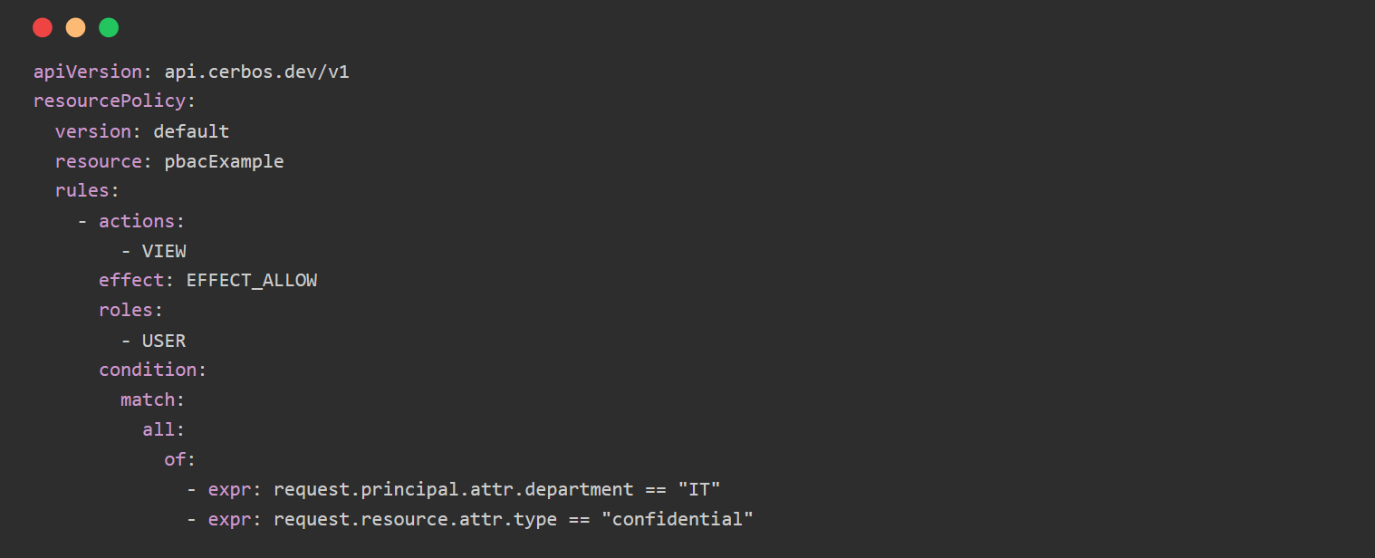

In this PBAC policy, access to confidential resources is granted based on the principal’s attributes pf department and the resource type. This showcases how PBAC allows for highly granular and context-specific access control.

**-Role-based access control (RBAC)** is an approach to restricting system access to authorized users. In RBAC, permissions are associated with roles, and users are assigned appropriate roles. This ensures that only users with the necessary role can access certain resources or perform specific actions.

RBAC is a helpful control model used by organizations to establish and police access to their digital resources. RBAC is widely accepted as an effective method of access control, particularly for organizations with an IT infrastructure and requirements that span a multitude of systems and applications. With RBAC roles and privileges can be easily assigned to users effectively regulating their activity within the system, reducing the threat of unauthorized access to sensitive information and ensuring the integrity of data that is vital to the smooth operation of the enterprise.

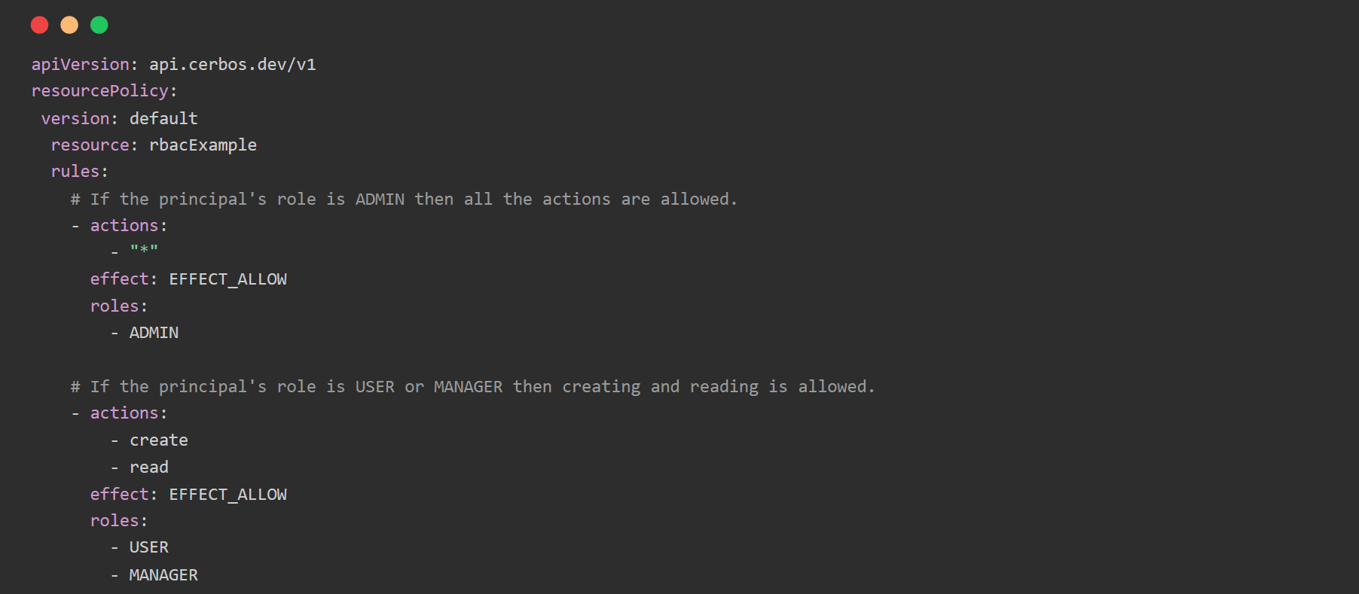

In this policy for a purchase order a user is granted permission to do defined actions based on their role. Admins can do all actions, users can create and read, and managers can also update a PO.

The following represent the key characteristics of a role-based access control system and are common to all such systems regardless of the size of the organization or the complexity of its digital infrastructure.

* Roles: For the purposes of access to digital assets roles are typically assigned based on job functions, responsibilities, and other attributes. For instance, within a given organization roles may include admin, manager, and employee. Each role is then assigned a variety of permissions based on the person’s job description. Some will have extremely limited access while others will have carte blanche.
* Permissions: RBAC relies on permissions being assigned to various roles. These permissions specify which digital assets a user will have access to along with the specific actions they will be able to perform in relation to those assets. For example, both an employee and a manager may be able to view a certain file but only the manager will have permission to alter its content or delete it.
* Users: Without users, there is no need for role-based access controls. Users are those individuals, processes or applications that need to interact with the system. Each user is assigned a role based on their responsibilities. In some cases, a user may be assigned more than one role.
* Resources: Resources - also referred to as “objects” - are those digital assets users will need to access, manipulate, or perhaps execute. Resources include files, databases, servers, scripts, and other components of the computer infrastructure.

**-Permissions-aware data filtering** is the process of fetching data based on a principal's access level. Instead of retrieving all the data and then filtering out unauthorized content, this approach fetches only the data the principal is allowed to access, ensuring efficiency and enhanced security.

Based on the access policies, Cerbos provides a list of conditions to apply in your data query, in order to only fetch the correct data points.

**-Cerbos Hub** includes a supercharged version of the playground with real-time collaborative editing experience where multiple users can work on policies at the same time.

* Real-time collaborative editing: Experience an editing environment where multiple users can work on policies simultaneously. Ideal for pair programming sessions, team reviews, and collaborative policy development. Ideal for reducing errors and enhancing policy reliability.
* Instant feedback and testing: Provides real-time feedback on changes, helping to quickly identify and resolve issues, and accelerate your policy development process. It also features an automated test runner, streamlining the policy testing process.
* Cohesive experience: Supports the creation of playgrounds directly from GitHub repositories for a cohesive development cycle.
* Policy evolution support: Facilitates the evolution of authorization policies with ease, integrating into your Git-based workflow. Encourages iterative development and continuous improvement of policy logic.

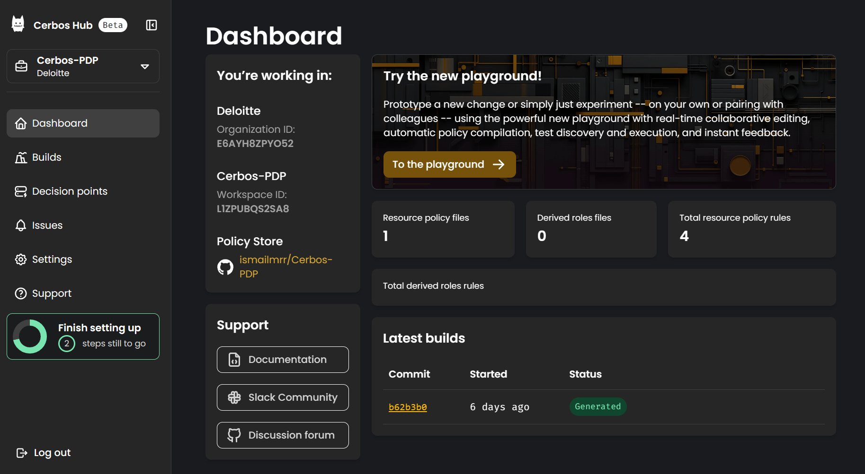

**-The Cerbos Playground** is an interactive online environment where users can write, test, and visualize Cerbos policies in real-time. It is designed to help both newcomers and experienced developers understand and experiment with Cerbos' capabilities without any setup or installation.

* Instant feedback: Write policies and see immediate results, streamlining the learning process.
* Zero setup: Dive straight into Cerbos without any installations or configurations.
* Safe environment: Experiment freely without any risks to your actual systems or data.
* Sample policies: Get started fast with pre-built examples for common application permission models.

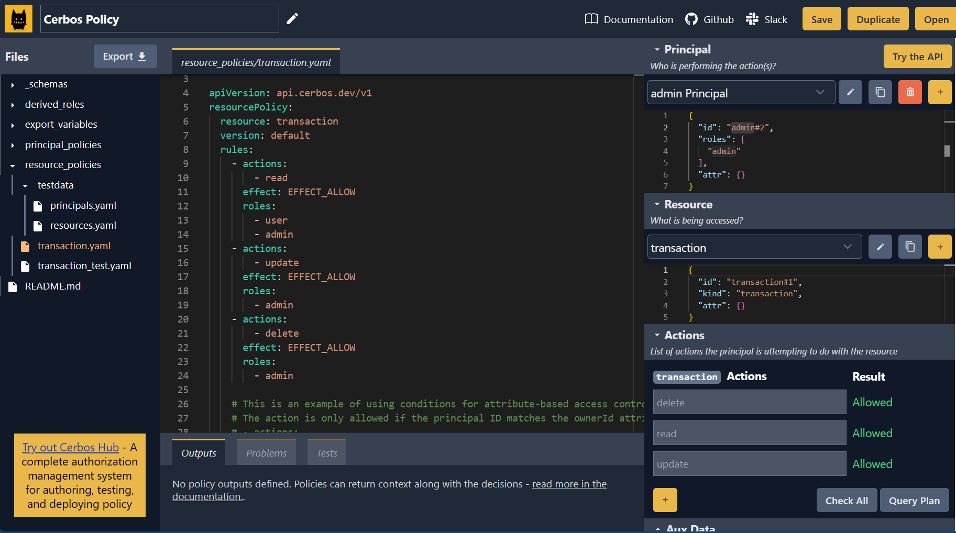

* + 1. Installation

For our project we decided to run Cerbos locally in our computer, we are going to install it as a container on docker using the following command:

docker run --rm --name cerbos -p 3592:3592 ghcr.io/cerbos/cerbos:0.36.0

By default, the container is configured to listen on ports 3592 (HTTP) and 3593 (gRPC) and watch for policy files on the volume mounted at /policies.

Here we can list the containers in our docker folder:

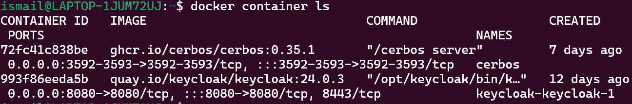

The first container is our Cerbos server container.

Or we can pull it directly from Docker hub on our Docker Desktop application,

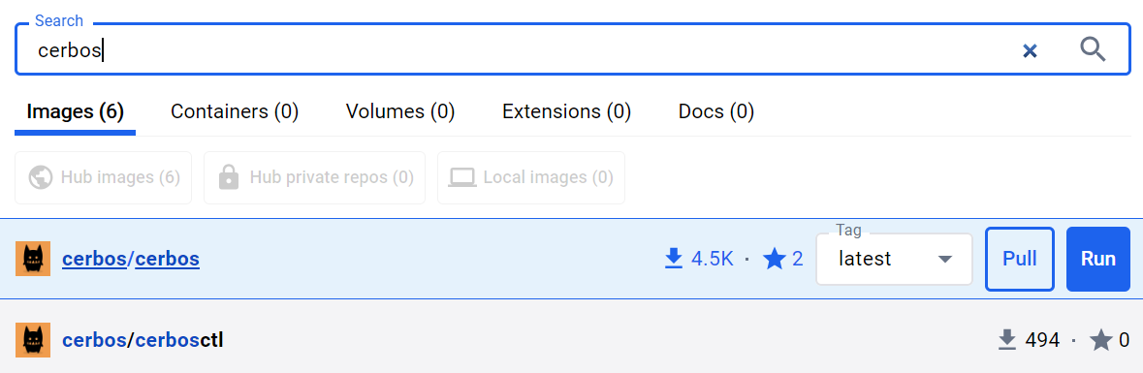

## Keycloak

## What is Keycloak

It is a tool for “Identity and Access Management”, Keycloak is going to be the identity provider in our architecture, users will be able to login using their credentials in the Keycloak login page. Additionally, Keycloak is an open-source tool currently licensed with Apache License 2.0. It is also an upstream project for Red Hat SSO, so if you are looking for something more enterprise-centered, you can check it.

The full list of supported platforms depends on which protocol you decide to use, currently Keycloak supports three different protocols, and can be viewed in documentation. Keycloak’s initial release took place in September 2014; the current version is 15.0.2 (2021-10-09). It is developed and maintained by people from Red Hat. It is now owned by Okta, a leader in Identity and access management.

## How does it work

IdPs are typically made up of three main components:

* A user identity store.
* An authentication system (with one or more authentication factors).
* Security protocols to prevent intrusion.

IdPs are a core component of enterprise IT infrastructure, allowing organizations to provision, authenticate, and manage user identities. In larger organizations, the task of assigning accounts to users and managing authorization can become overly complex, and IdPs make it possible to scale up the number of users, reduce overhead for IT teams, and ensure strong access control.

Identity providers are also increasingly important in provisioning of cloud services. Cloud-based services must grant their users accounts, securely authenticate them, and manage user workflows such as onboarding and account cancellation. IdPs can support these activities as well.

IdPs use languages such as **Security Assertion Markup Language (SAML)** and data formats such as **Open Authorization (OAuth)** to communicate with each other and with other web service providers.

IdPs are responsible for transporting three basic types of messages: an authentication assertion indicating who the requesting device is or what the claiming device is, an attribution assertion that carries all relevant data when making a connection request, and an authorization assertion that records whether a user or requesting device has access to an online resource.

These assertions are typically Extensible Markup Language (XML) documents that contain all the information needed to authenticate the user to the service provider.

Keycloak uses **JSON Web Tokens (JWTs)** as the primary means of representing and exchanging authentication and authorization data. Here's how Keycloak works with JWTs:

**Token Issuance:** When a user successfully authenticates with Keycloak, it issues two types of JWTs:

* **Access Token**: This token contains information about the user, such as their identity, permissions (e.g., roles, groups), and potentially other custom claims. The access token is typically short-lived and is used by the client application to access protected resources on behalf of the user.
* **ID Token**: This token contains basic information about the user's identity, such as their username, email, and potentially other profile attributes. The ID token is typically used for user authentication and user profile management.

**Token Structure**: JWTs issued by Keycloak are encoded in the form of JSON objects, which are then signed using JSON Web Signature (JWS) to ensure their integrity and authenticity. The JWT consists of three parts:

* **Header**: Contains metadata about the token, such as the signing algorithm used.
* **Payload**: Contains the actual data of the token, including user claims (e.g., username, roles) and additional metadata.
* **Signature**: A cryptographic signature generated using the private key of the Keycloak server, which is used to verify the authenticity of the token.

**Token Verification:** When a client application receives a JWT from Keycloak, it can verify the token's authenticity by:

* **Decoding**: The client decodes the JWT to extract the header and payload.
* **Signature Verification**: The client validates the signature using the public key of the Keycloak server to ensure that the token has not been tampered with.
* **Token Expiry:** The client checks the token's expiration time (expiration claim) to ensure that it has not expired.
* **Audience Verification**: Optionally, the client may verify that the token is intended for its audience by checking the audience claim.

## Keycloak features

**Single-Sign On**

Users authenticate with Keycloak rather than individual applications. This means that your applications don't have to deal with login forms, authenticating users, and storing users. Once logged-in to Keycloak, users don't have to login again to access a different application.

This also applies to logout. Keycloak provides single-sign out, which means users only have to logout once to be logged-out of all applications that use Keycloak.

**Identity Brokering and Social Login**

Enabling login with social networks is easy to add through the admin console. It's just a matter of selecting the social network you want to add. No code or changes to your application is required.

Keycloak can also authenticate users with existing OpenID Connect or SAML 2.0 Identity Providers. Again, this is just a matter of configuring the Identity Provider through the admin console.

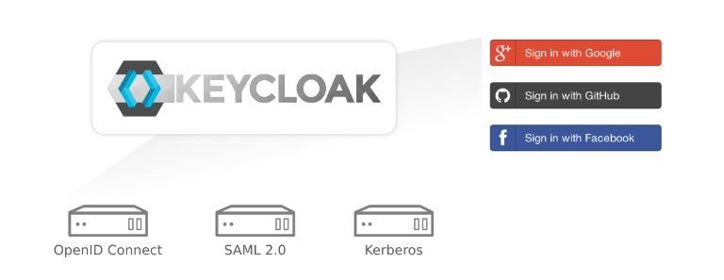

**User Federation**

Keycloak has built-in support to connect to existing LDAP or Active Directory servers. You can also implement your own provider if you have users in other stores, such as a relational database.

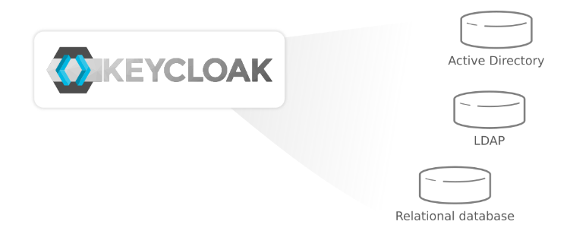

**Admin Console**

Through the admin console administrators can centrally manage all aspects of the Keycloak server. They can enable and disable various features. They can configure identity brokering and user federation. They can create and manage applications and services and define fine-grained authorization policies. They can also manage users, including permissions and sessions.

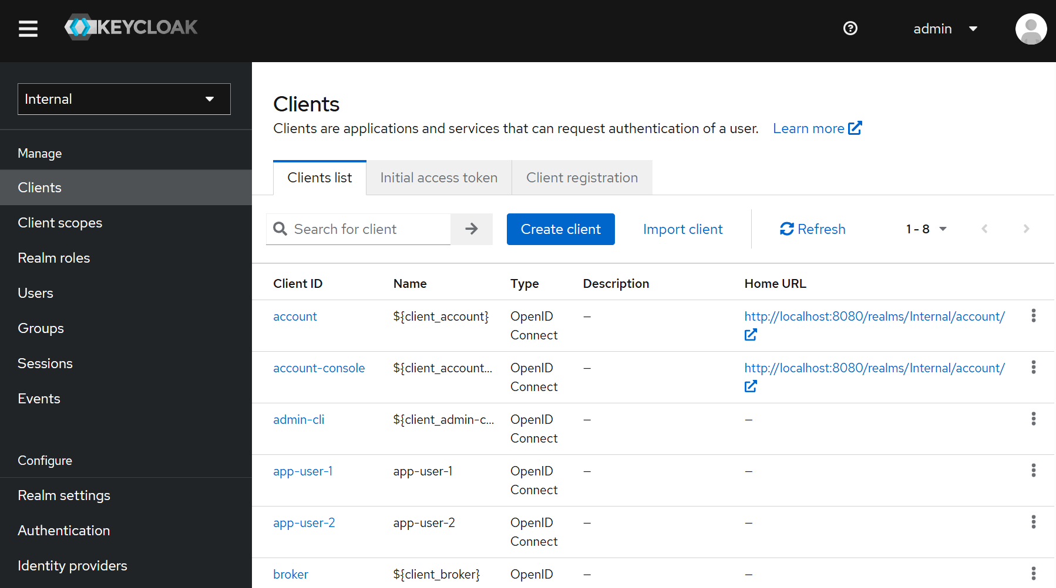

Here are some other features of Keycloak,

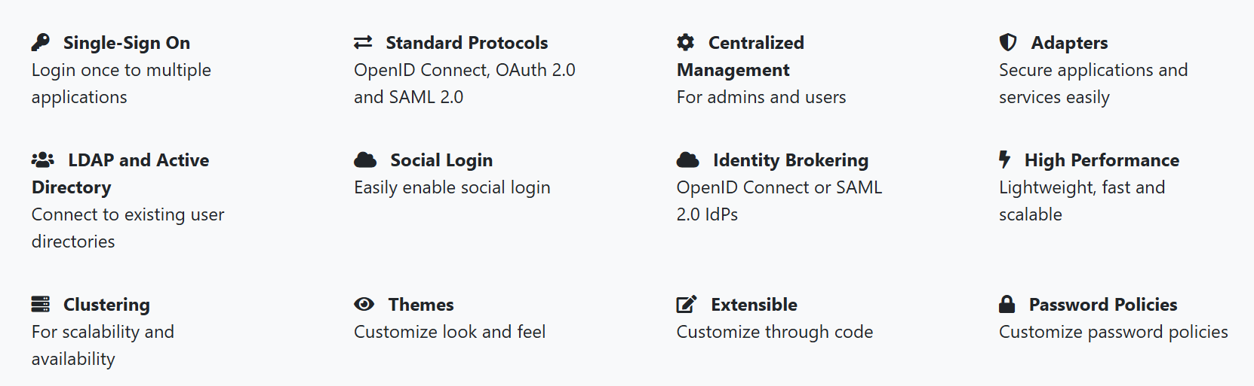

## Installation

For the Keycloak installation we are going to use Docker Compose, Docker Compose is a tool for defining and running multi-container applications. It is the key to unlocking a streamlined and efficient development and deployment experience.

Compose simplifies the control of your entire application stack, making it easy to manage services, networks, and volumes in a single, comprehensible YAML configuration file. Then, with a single command, you create and start all the services from your configuration file.

The reason we are using compose for this part is because we want to create a network ad open the ports of Keycloak to that network.

We can also use the traditional way by pulling the Keycloak image from docker hub and running it,

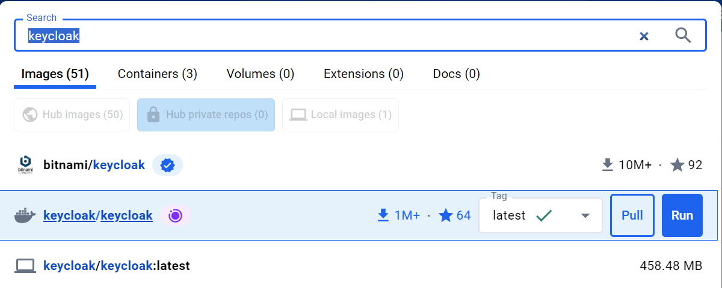

In docker compose here is the configuration and the YAML file we will use.

First, we create a directory called Keycloak and we move to that directory,

mkdir Keycloak

cd Keycloak

then we create the docker compose file using this command

nano docker-compose.yaml

then we paste this yaml text

V2.1

services:

keycloak:

image: quay.io/keycloak/keycloak:24.0.3

environment:

- KEYCLOAK_ADMIN=admin

- KEYCLOAK_ADMIN_PASSWORD=admin

ports:

- "8080:8080"

networks:

- keycloak-net

command: start-dev

networks:

keycloak-net:

internal: true

external: true

Then we click on ^X to exit and on Y to save, this will automatically pull the version of Keycloak we specified in the compose file, then we can access our Keycloak admin on <http://localhost:8080/> , 8080 is the port Keycloak is listening on.

## Project scenario and Use-Cases

## Scenario

X-Financials, a company specializing in financial services, has just suffered a cyberattack that caused significant damage. An employee from the marketing team fell victim to a phishing email, which led to a ransomware infection. This quickly affected the company's other systems as the system was not isolated. The IT department at X-Financials is seeking to strengthen the security of its IT infrastructure to protect its sensitive data against the increasing threats of cyberattacks.

In this context, X-Financials has developed an IAM (Identity and Access Management) system based on the Zero Trust principle to be implemented throughout the organization. This system aims to ensure strict authentication and authorization of the company's employees and clients, limited access to sensitive data, and visibility over all access points.

## Use-cases

|  |  |  |  |
| --- | --- | --- | --- |
| Priority | Use-Case | Description | Pros |
| 1 | Least privilege access | In X-Financials, clients' financial data such as transactions and balances are stored in a centralized system. This data is extremely sensitive, and access must be strictly controlled to protect client confidentiality and prevent risks of fraud, identity theft, or lateral movement.  Applying the principle of least privilege will limit the access of users and systems. When a user logs into the system, they only have access to the resources and permissions necessary to perform their specific tasks.  Thus, with their new IAM Zero Trust system, the employee in the finance department of X-Financial has access to all clients' financial transactions and information; employees in the HR department do not have this type of access; and clients only have access to their own transactions and information. | Reduces security risks by limiting access to essential resources for the specified function, thereby minimizing opportunities for attacks and data leaks. |
| 2 | Context based access control | The Zero Trust architecture uses context-based access control to assess the risk of login attempts. In this context, employee X from the Human Resources department of X-Financials typically logs in from Morocco. It was observed that he attempted to connect remotely from a new device and from India. Thanks to the context-based access control of the Zero Trust architecture, this user's login attempt is evaluated, and a verification code (MFA) is sent to his phone to grant him access to sensitive resources. | Context-based access control in the Zero Trust architecture enhances security by assessing the risk of login attempts and applying additional authentication measures based on the risk level. This helps prevent unauthorized access to sensitive resources. |
| 3 | Multi-Factor Authentication and continuous authentication | To prevent cyberattacks due to identity theft, employees need secure access to systems to manage transactions and provide effective customer service. Unauthorized access could compromise the security of customer accounts and lead to financial losses.  Therefore, X-Financial has implemented a continuous authentication mechanism such as multi-factor authentication (MFA). For example, if an employee uses the same password for both.  personal and professional accounts, it presents a vulnerability. With MFA, even if an attacker manages to steal the employee's identity, they will be prompted to authenticate a second time using a unique code that is renewed every 15 seconds, thereby denying the attacker access. | It makes access more secure by requiring multiple forms of authentication, while continuous authentication actively monitors user activity to prevent unauthorized accesses. |
| 4 | Resource segmentation | In the Zero Trust architecture, strict network segmentation and data classification are implemented. In this context, in the company X-Financials, sensitive data is classified based on its level of confidentiality, using the categories "public," " confidential," and " high risk confidential." After a successful authentication, an employee from the Finance department attempts to access a database containing confidential financial information of the company. Thanks to the access management for classified data, additional authentication is required before granting access. This is achieved by configuring an additional MFA layer for data classified as " high risk Confidential." | The data classification in the Zero Trust architecture enhance security by reducing the attack surface and limiting unauthorized access to sensitive resources. This helps protect the valuable data of the company against intrusion attempts. |
| 5 | Denied access monitoring | In a context where cyber threats are becoming increasingly sophisticated, companies must strengthen their security posture by proactively monitoring unauthorized access attempts to their systems and sensitive data.  For example, when an employee from the HR department of X-Financials repeatedly attempts to access sensitive financial information that is not within their access scope (fine-grained access control), the system alerts the system administrator through alerts sent within the internal system or to an external SIEM system of the company. | It provides granular and rapid detection of threats and suspicious activities or unauthorized access to sensitive data, enabling security teams to react promptly and strengthen their security posture. |
| 6 | User behavior analysis | The Zero Trust architecture incorporates user behavior analysis to detect suspicious activities. In this regard, company X-Financials utilizes the Zero Trust architecture and has an IT resource management system. Within this system, it was noticed that an employee from the Sales department is attempting to access sensitive data repeatedly outside of their usual working hours. Thanks to User Behavior Analysis (UBA) integrated into the Zero Trust architecture, an alert was received indicating unusual activity from the employee. This allows for a quick investigation to determine whether it is a security breach or legitimate behavior, enabling rapid response to potential security breaches. | Enables early detection of suspicious activities, which helps prevent security breaches. By quickly identifying abnormal behaviors such as unusual access to sensitive resources, corrective measures can be taken to minimize potential damage. |

On the implementation part, we will be focusing on the 3 first use-cases.

## Technical architecture and implementation

## Technical architecture

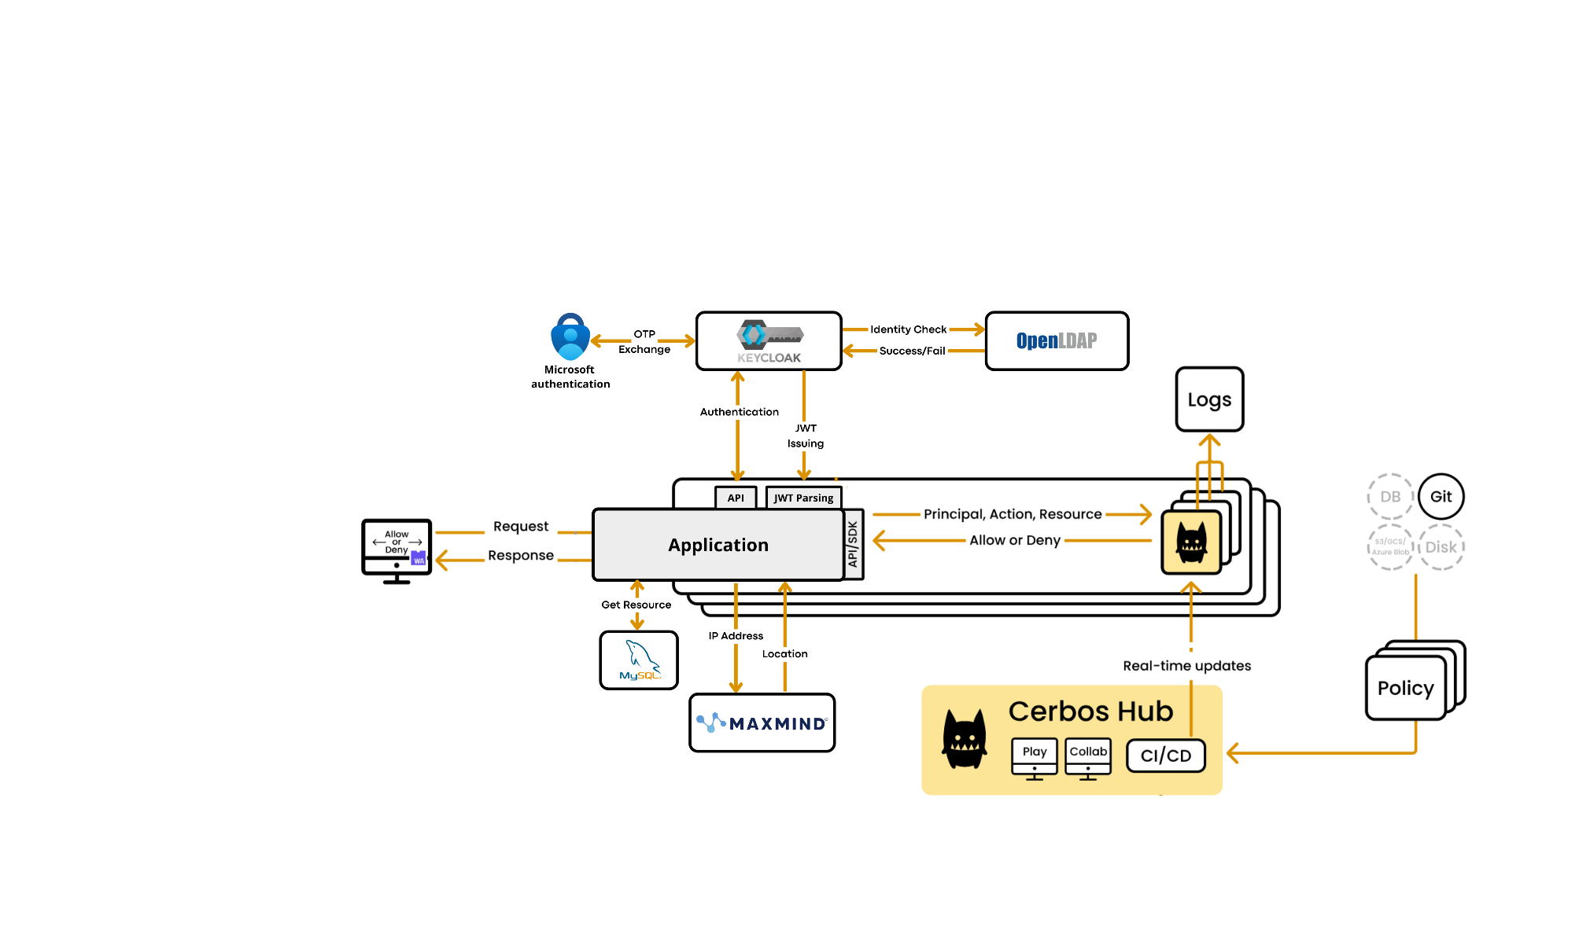

Explanation

## Implementation

## Cerbos initial configuration

First, we need to create a Cerbos Hub account to be able to deploy our Policy Decision Point,

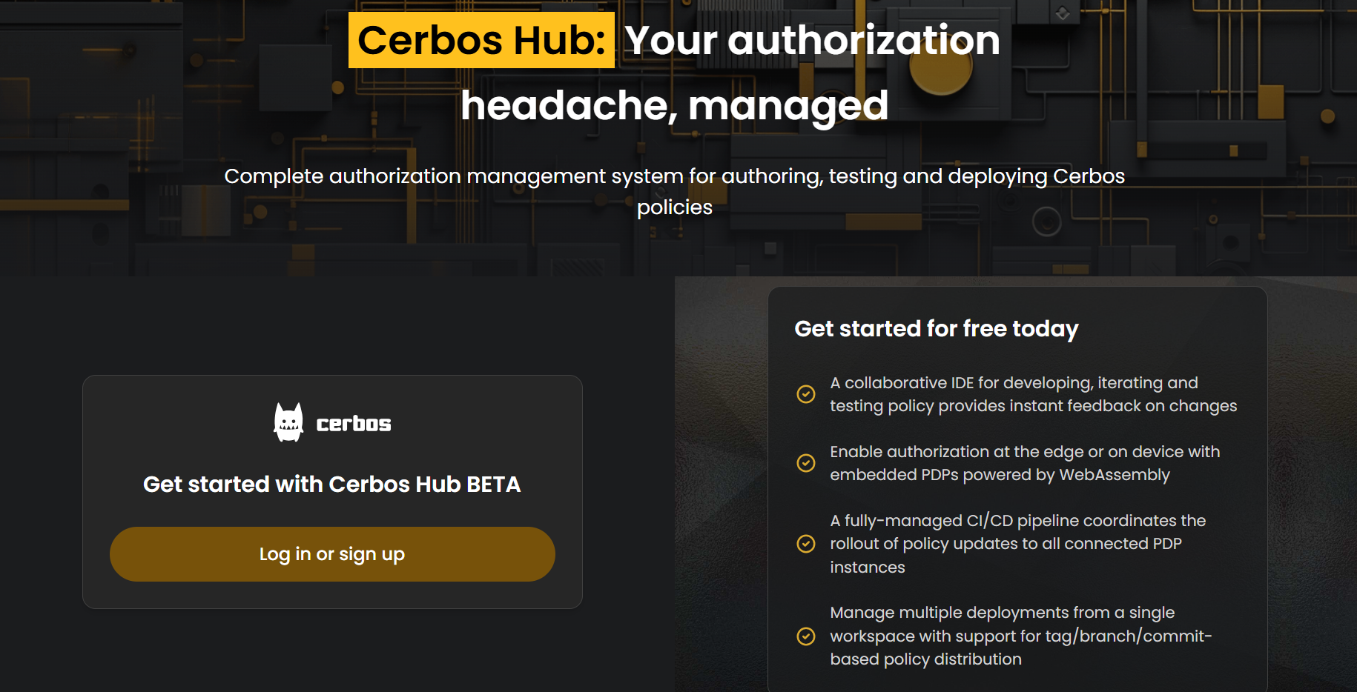

When we are logged in, we are prompted with this dashboard,

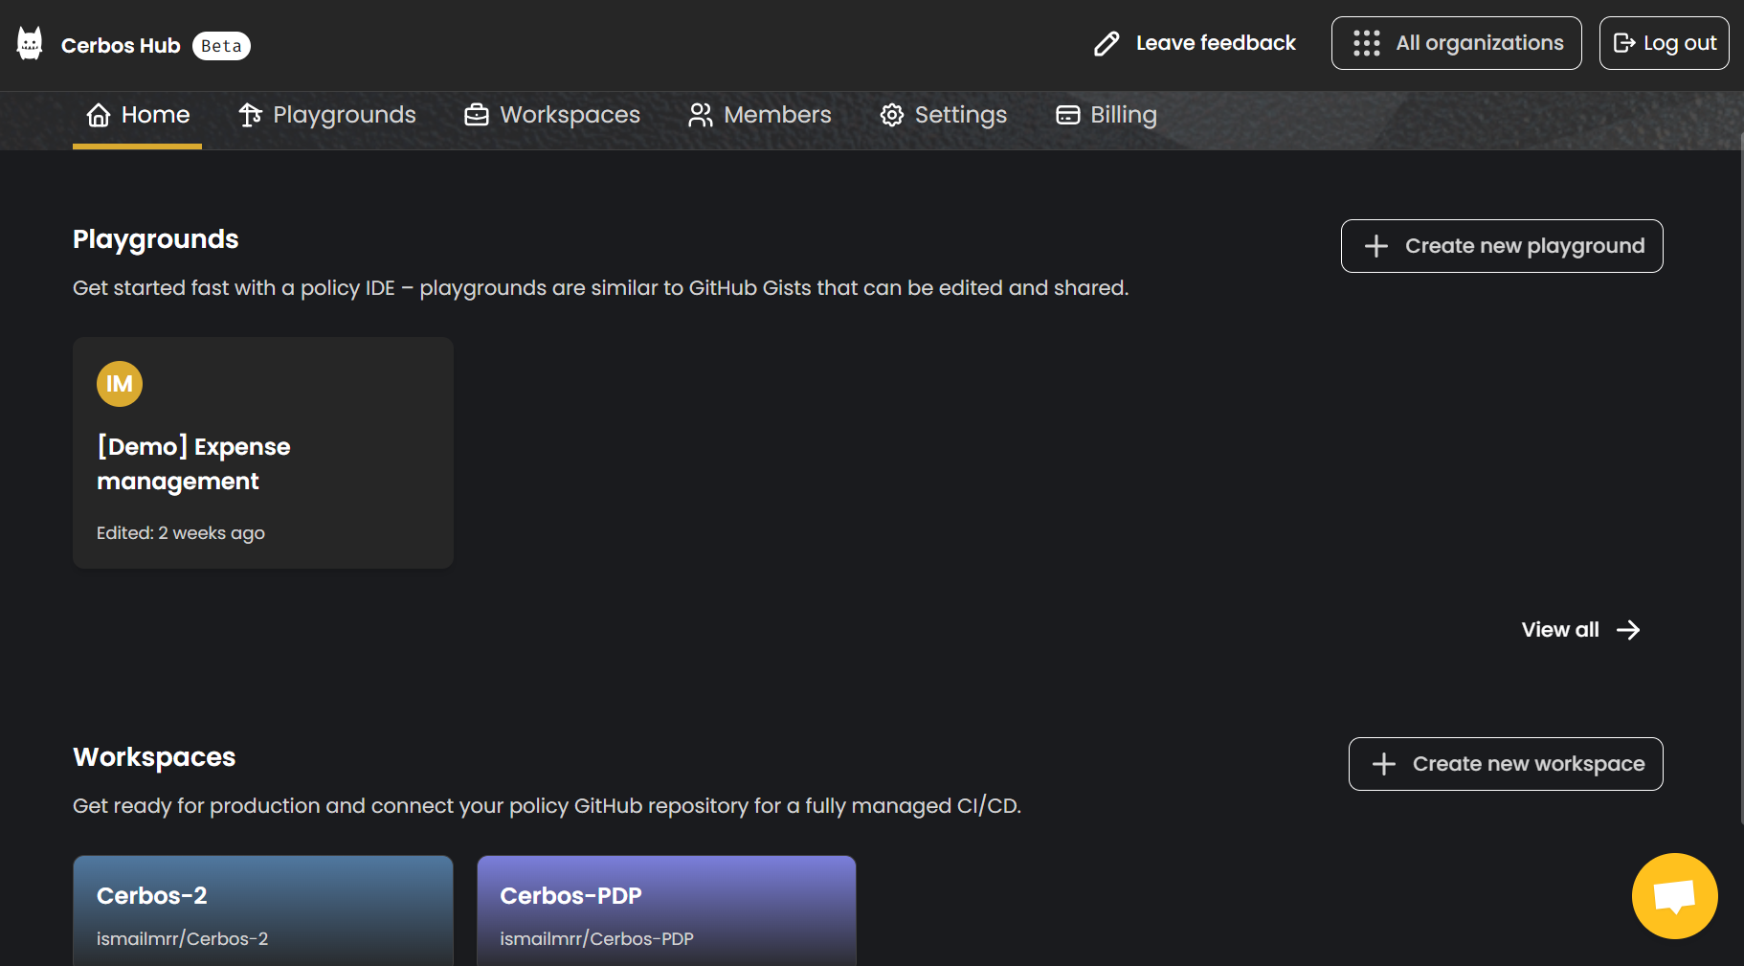

Here we can access Cerbos playground where we write and test our policies, the “Expense management” playground is where we created our policy. We also have the workspaces where we input the path to our policy file and create/deploy our policy decision points.

Let’s start by creating our policy in Cerbos Playground.

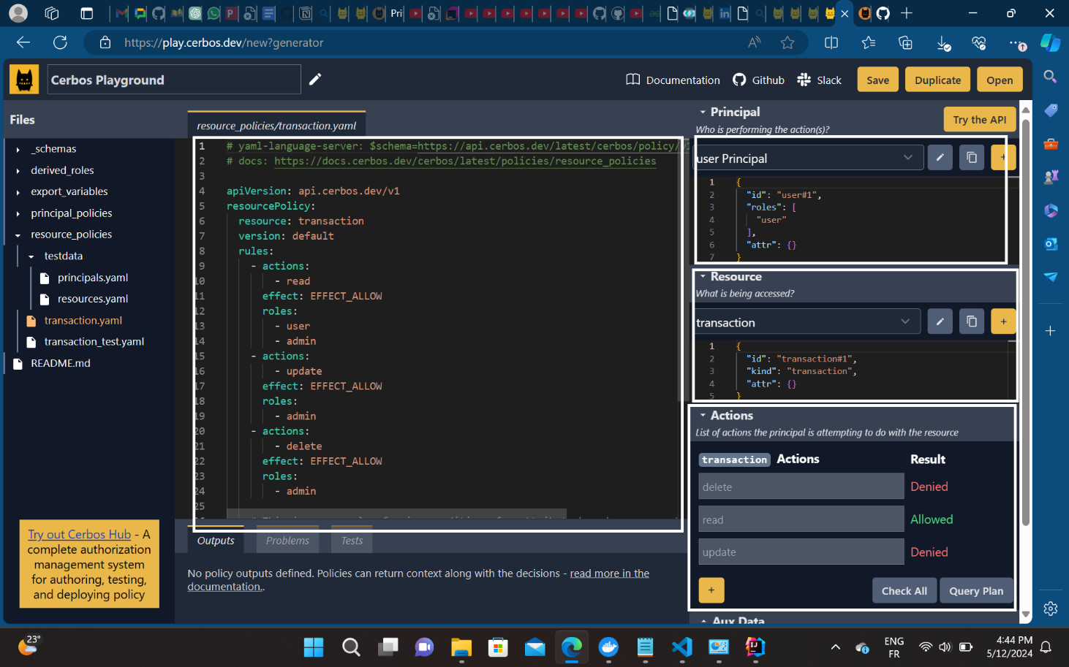

There are four principal parts in this dashboard,

**Principal:** This part contains the user attributes, these attributes must match the ones in the JWT coming from Keycloak, so that when the policy decision point tries to compare attributes to make a decision, we get an “effect allow”. We can see that the User Principal has an “id” of “user1” and a “role” of “user”, these are mandatory attributes, but we can also add other attributes like e-mail, location, etc...

**Resource:** This part contains the resource attributes, these also must match the ones in the MySQL database. The resource has an attribute of “id” and “kind”.

**Actions:** For this example, we have three actions, “read” “delete” and “update”. Each user role is only allowed to do some actions, for example the user can only read the resources, on the other hand, the admin can read, update and delete the resource.

**Effect:** Is the decision we make for each scenario, in our example it’s EFFECT_ALLOW.

After making our policy in the Playground we can export it and copy it into our code directory, then we must push our code into Github to be able to connect Github to our Cerbos instance.

To do that we need to enter these commands in our editor’s terminal and get the link of our Github repository.

git init

git add .

git remote add origin https://github.com/ismailmrr/Cerbos-PDP.git

git branch -M main

git commit -m "first commit"

git push -u origin main

Now that the code is pushed successfully, our policy repository needs a “.cerbos-hub.yaml” file, which defines labels for Git references. Cerbos Hub will compile and test your policies from commits matching the labels.

We create the file in our repository and copy the code provided by Cerbos into it.

apiVersion: api.cerbos.cloud/v1

labels:

latest: # 'latest' label pointing to the HEAD of the main branch

branch: main

v2.0: # 'v2.0' label pointing to the commit tagged 'v2.0'

tag: v2.0

specificCommit: # 'specificCommit' label pointing a single commit

commitHash: aed2f40b9ef115ea3a6eb5273dad56f0ddcffa39

then we connect to Github

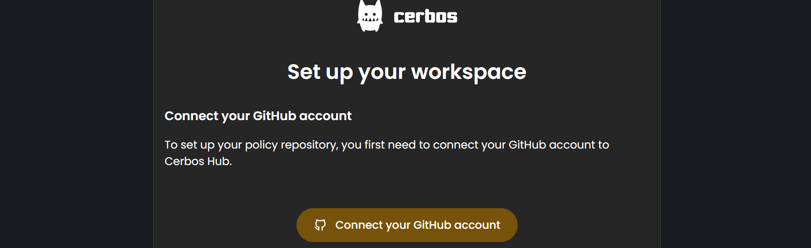

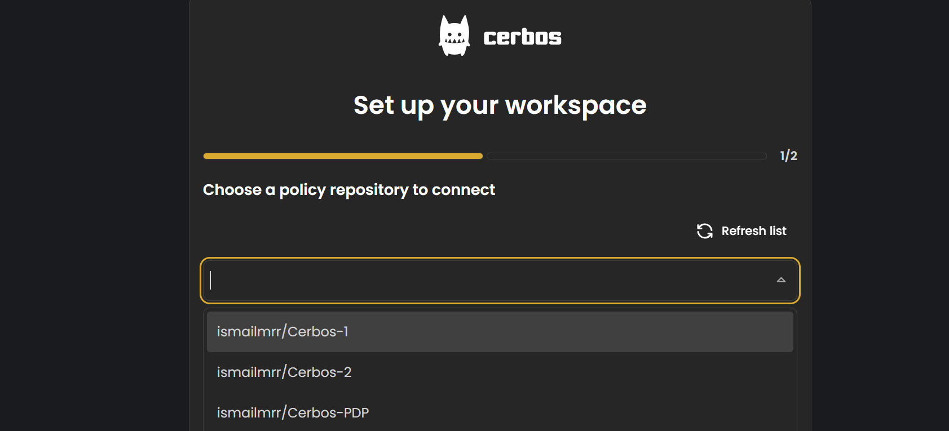

Here we choose the repository we have pushed into Github, in our case it’s the Cerbos-PDP. And then in the 2nd step we have to enter the name of the folder that contains our policy file or the path in the Github directory, in our case it is “Cerbos/policies”.

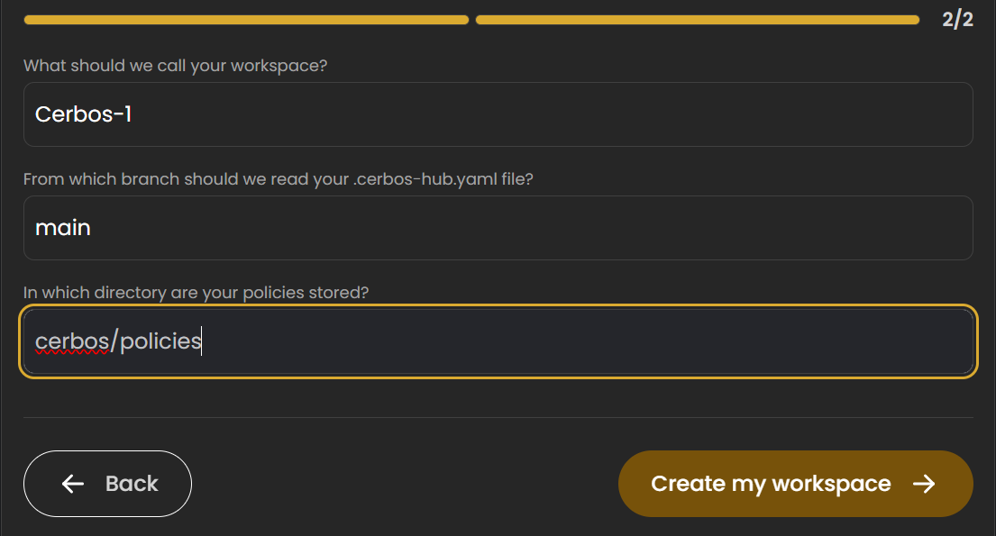

The creation of the workspace is successful. Now lt’s create our Policy Decision Point (PDP).

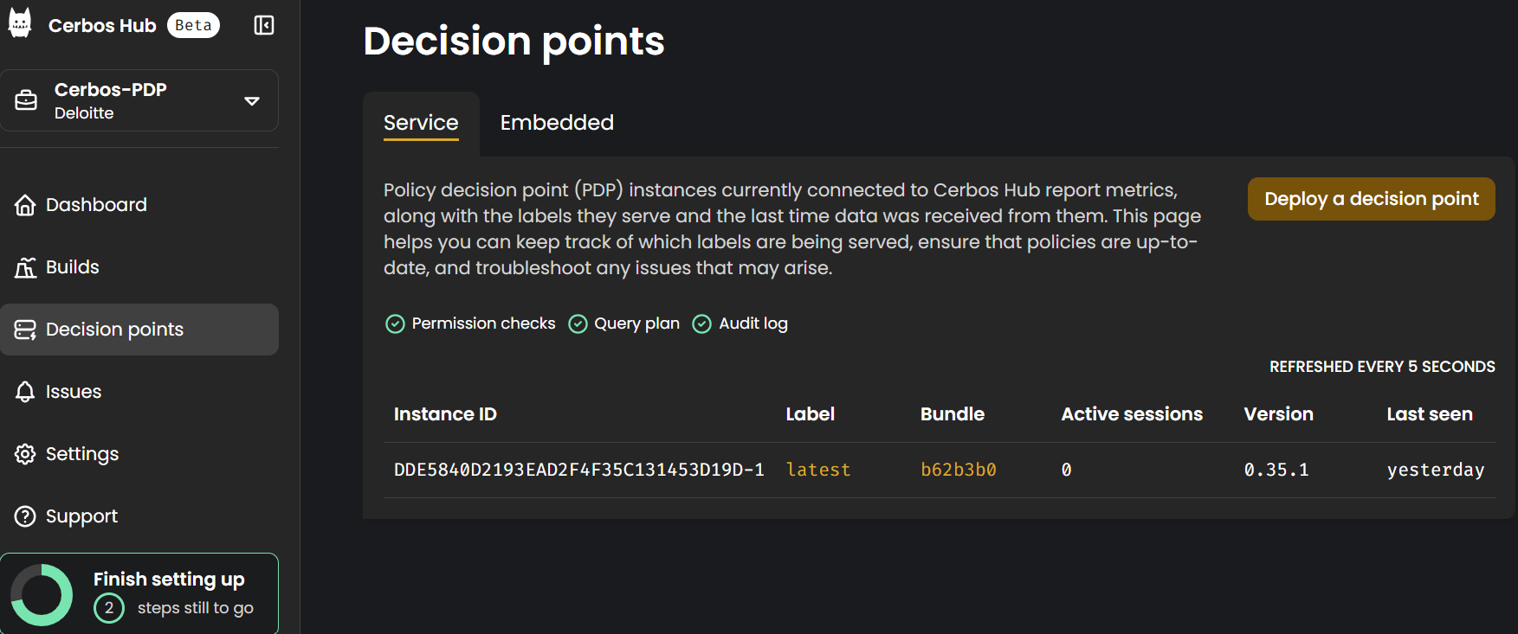We click on “Deploy a decision point”, 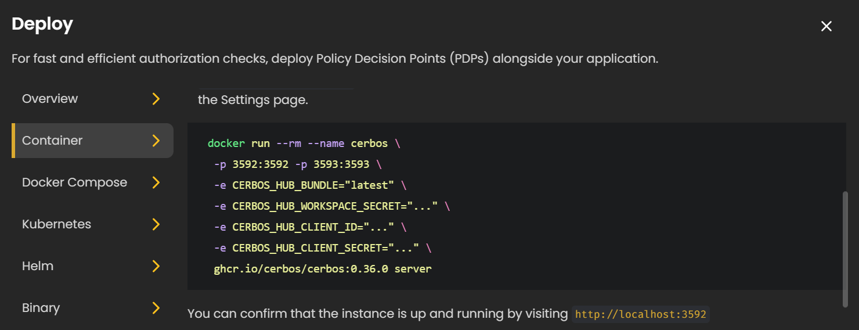

We will deploy it as container on Docker using the command provided on the figure, we will replace the workspace secret with the secret we got from Cerbos, the client id and client secret are going to be generated from the client’s menu as follows,

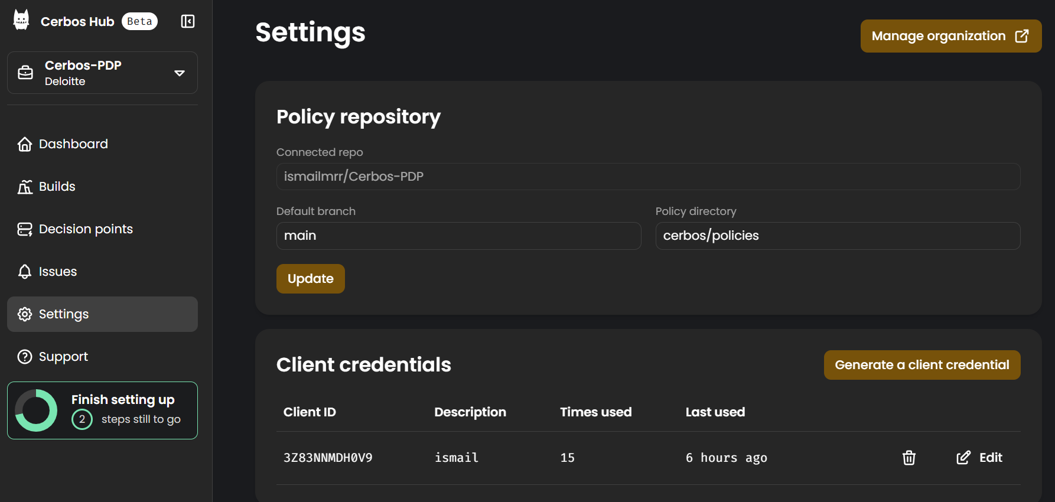In the settings sections, on the client credentials part we click on generate a client credential, 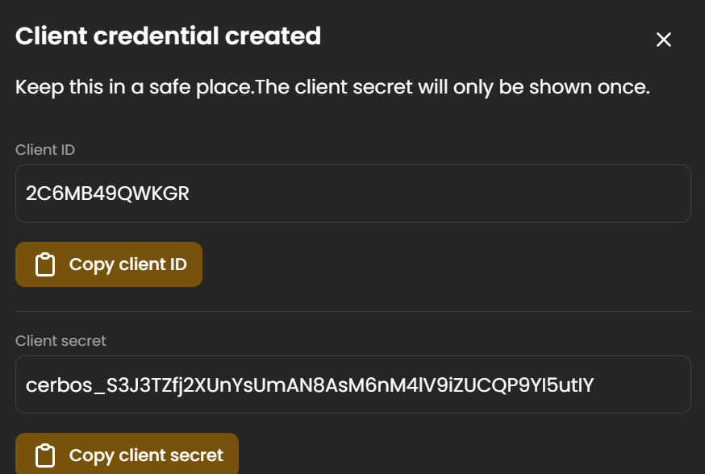

After we replace the ID and secret we will get a command like this that we run in th terminal after activating docker,

docker run --rm --name cerbos \

-p 3592:3592 -p 3593:3593 \

-e CERBOS_HUB_BUNDLE="latest" \

-e CERBOS_HUB_WORKSPACE_SECRET="CERBOS-1L1ZPUBQS2SA8-CAHX3N87XKHY6UC

D3WQNGK7D42HKMKNPN2HFJN8XU746YNXY2Q6QVCP5Q5" \

-e CERBOS_HUB_CLIENT_ID="3Z83NNMDH0V9" \

-e CERBOS_HUB_CLIENT_SECRET="cerbos_S1FkByOccqQt/qozw7RH8iCkKgZqPcUHYlJ

m40AHWEY" \

ghcr.io/cerbos/cerbos:0.35.1 server

After successful execution of the command we can see our policy decision point with the appropriate ID on the dashboard as follows,

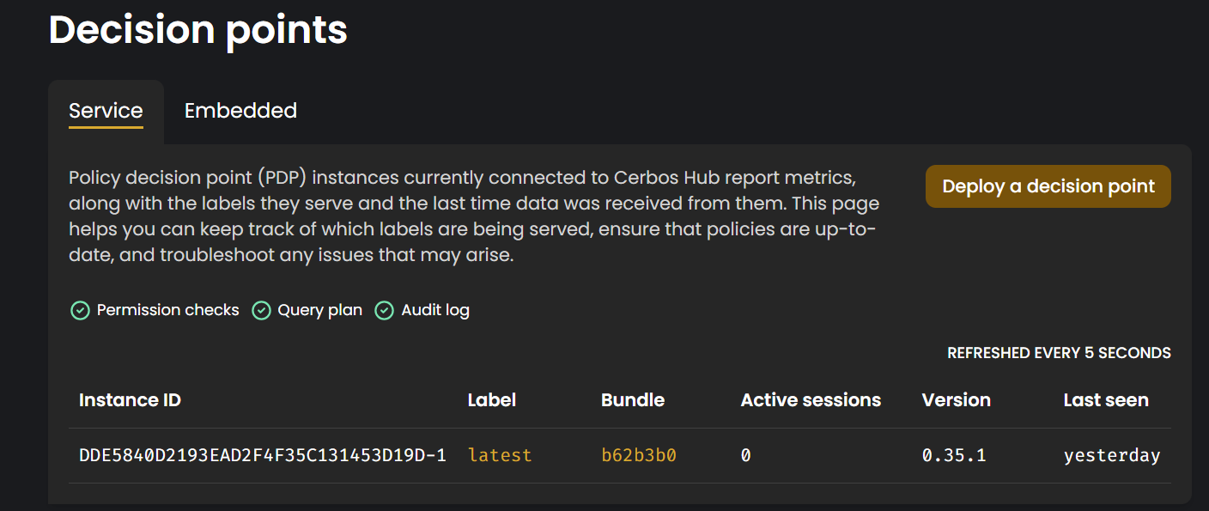

## Keycloak initial setup

## Keycloak server deployment

**Step 1: Configure the Keycloak server.**

We used Docker to quickly provision a Keycloak server. The command in the docker compose file mentioned earlier allows you to deploy a development Keycloak server on port 8080. The default username and password are set to "admin".

We have used version 24.0.3 of Keycloak in this guide.

We go to <http://localhost:8080> to check if the Keycloak server is running.

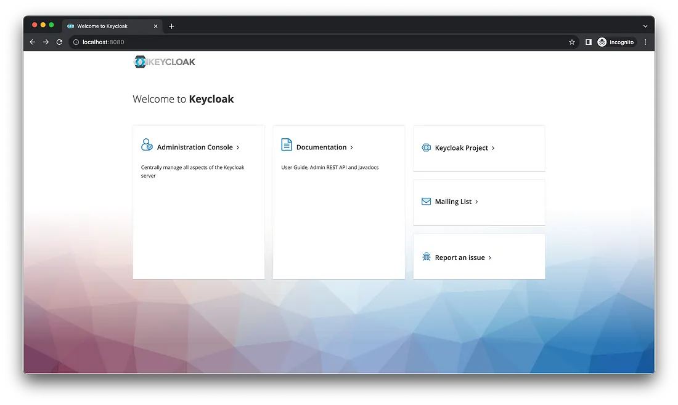

*Figure 4.12: Page d’accueil de Keycloak*

**Step 2: Log in to the Keycloak Security Administration Console**

We access <http://localhost:8080/admin> and log in using the username "admin" and the default password “admin”. By default, we are connected to the "master" realm.

A realm is a logical container that brings together a set of users, applications, and resources. It is an independent authentication and authorization space.

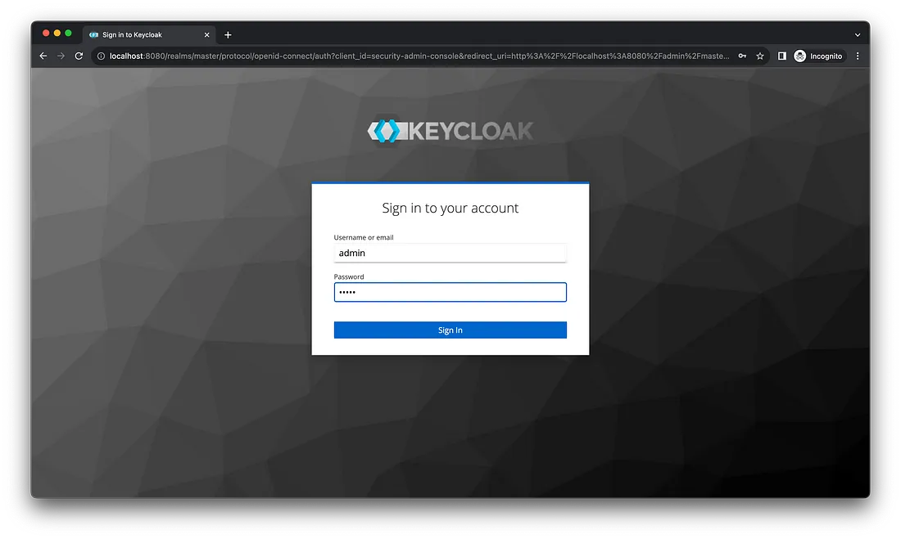

*Figure 4.13: Keycloak authentication page*

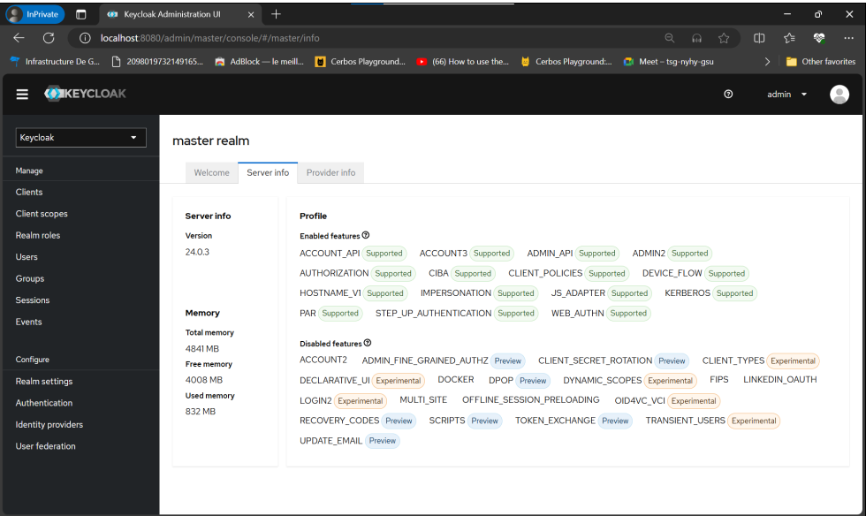

*Figure 4.14: Home page of the "master" realm*

**Step 3: Create a new realm.**

Keycloak comes with a default realm named "master". A realm is similar to a container and manages a specific set of users, credentials, roles, and groups. The default "master" realm should only be used to administer Keycloak himself. To manage our applications, we need to create a new realm. We will use the following link to add a new realm that we will name "external".

<http://localhost:8080/admin/master/console/#/master/add-realm>

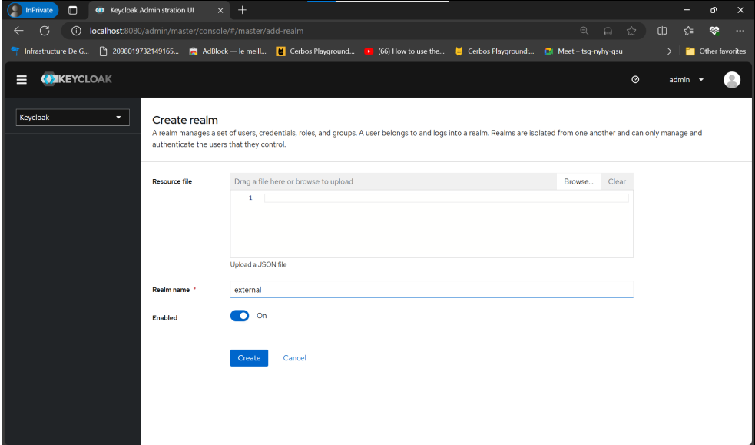

*Figure 4.15: Creation of a new realm*

**Step 4: Create a client under "external".**

Customers are entities that can request that Keycloak authenticate users. In our case, the Next.js application will be the customer. Keycloak offers two types of clients: OpenID Connect and SAML. We are going to focus only on OpenID Connect.

We access <http://localhost:8080/admin/master/console/#/external/clients/add-client>.

We select the client type "OpenID Connect" and set the client ID to "nextjs". We click "Next" to continue.

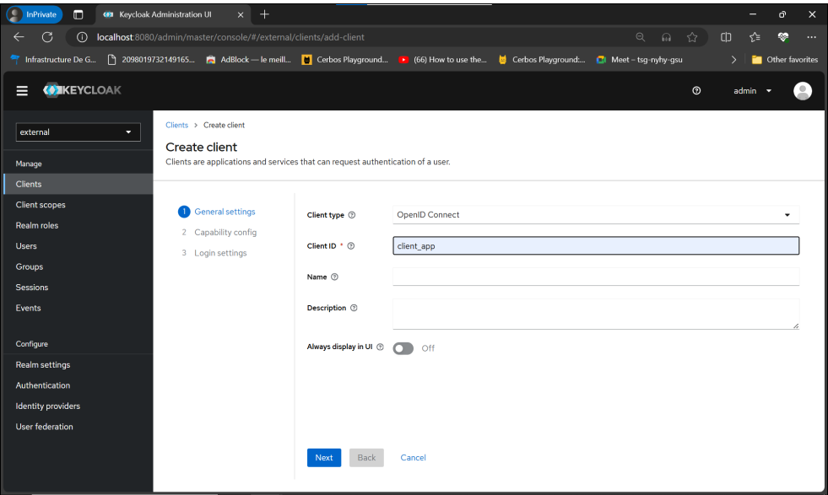

*Figure 4.16: Creating a client under the "External" Realm*

To enable client authentication, choose the standard flow for the authentication process. Next, click "Next" to configure the connection settings.

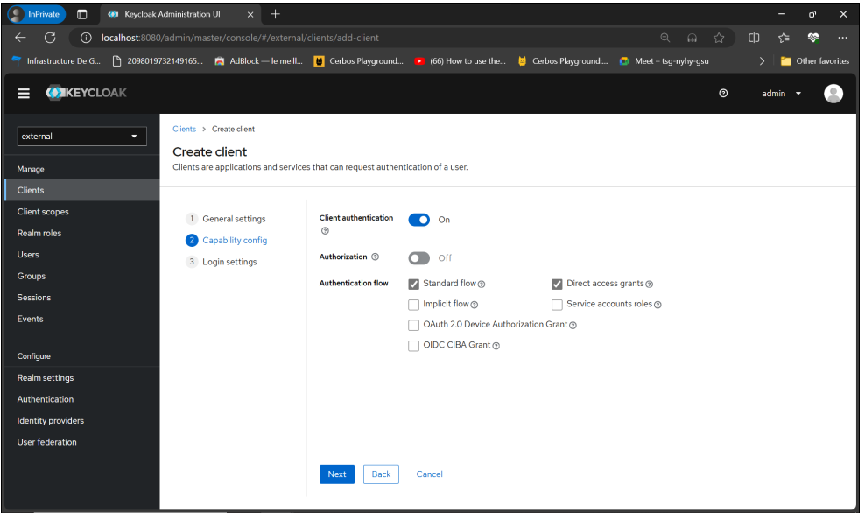

*Figure 4.17: Client Configuration*

Details of the redirect URIs can be found in the next-auth library's REST API documentation. Since we'll be developing our own logout feature, we'll use the Next.js app URL as the post-logout redirect URI. The URL will be <http://localhost:3000>.

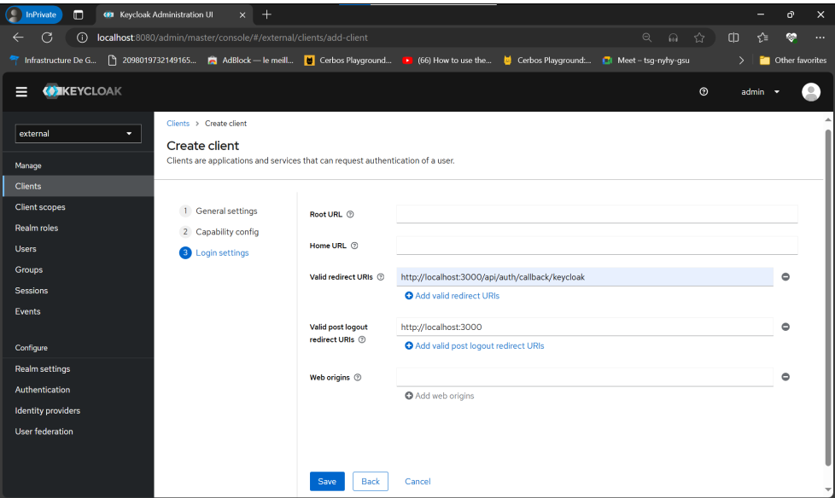

*Figure 4.18: Configuring Authentication Settings in Keycloak*

We click on "Save" to create the client.

**Step 5: Retrieving the client secret of the client identifier "client_app"**

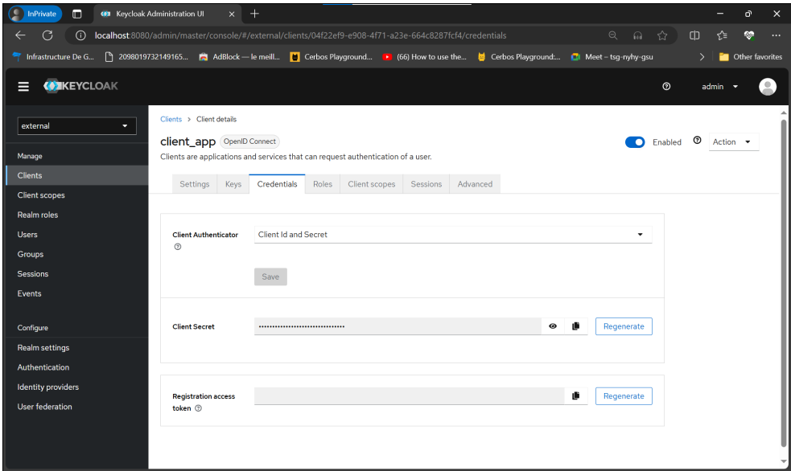

*Figure 4.19: Customer credentials*

## OpenLDAP Configuration with Keyclaok for User Federation

## Adding an OpenLDAP directory to Keycloak

* **Access to the user federation**: We must first open the Keycloak administration console and access the **User federation menu**.
* **Selecting the Provider Type**: A list of adapters representing the different types of user storage providers is displayed. Select the card that corresponds to the type of provider you want to add (for example, LDAP).

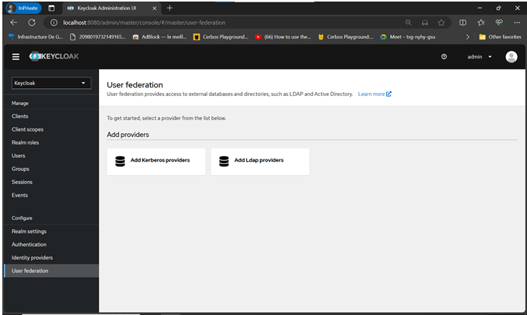

*Figure 4.20: User federation in Keycloak*

Keycloak then automatically redirects to the configuration page dedicated to that specific provider.

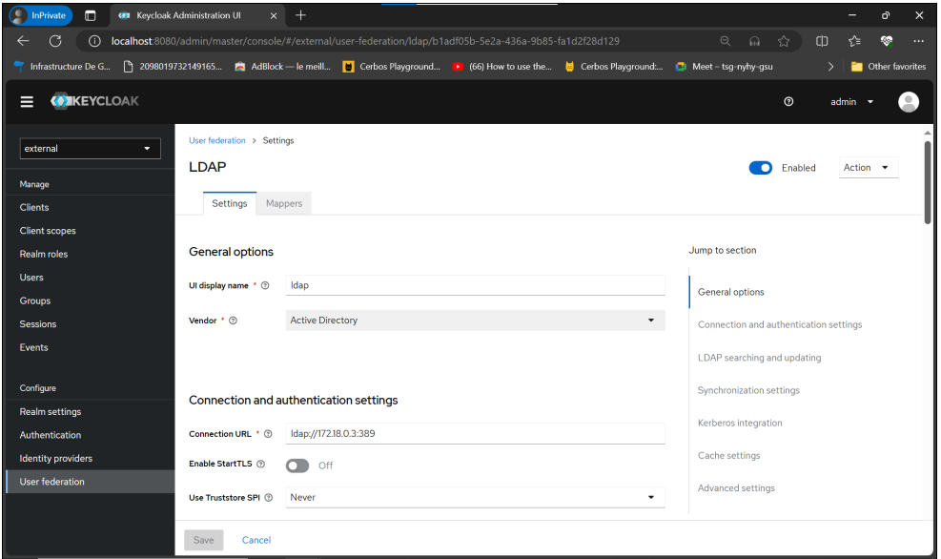

*Figure 4.21: Configuring LDAP User Federation*

**-Retrieving user structure and property information**

The first step is to retrieve the structure and properties of the users stored in the OpenLDAP directory. Using a phpLDAP administration tool makes this task easier.

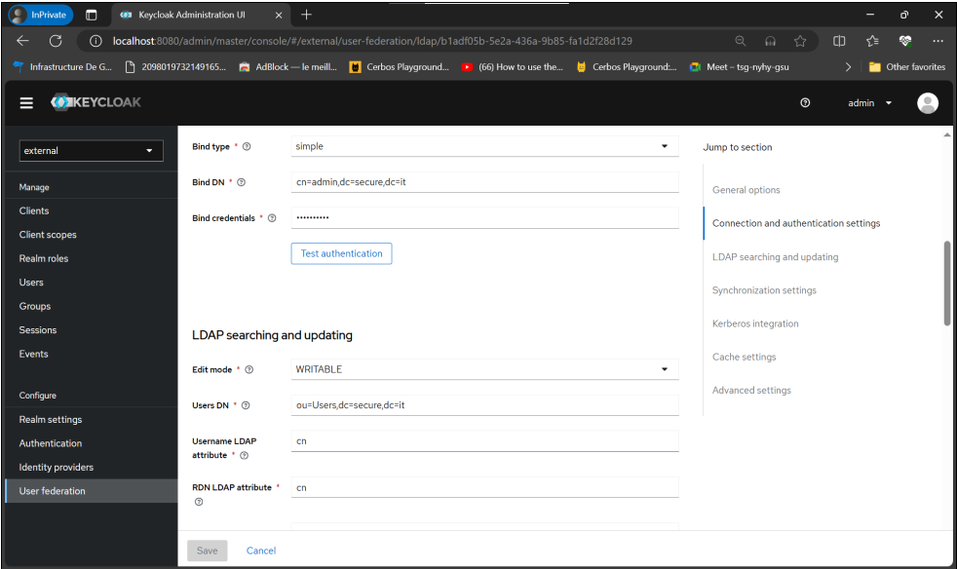

*Figure 4.22: Configuring LDAP Connection Settings*

**-Configuration LDAP dans Keycloak**

Once we have the necessary information, you can configure the OpenLDAP provider in Keycloak.

Here are the things to consider when setting up:

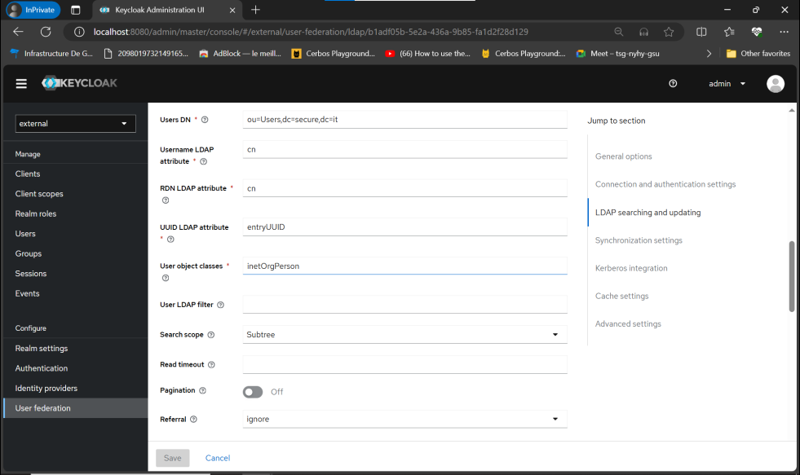

*Figure 4.23: Configuring LDAP Connection Settings*

**Important**: It is recommended that you do not rely on the default values offered by Keycloak in the "provider" section. We use a phpLDAP explorer to check the exact values of our directory.

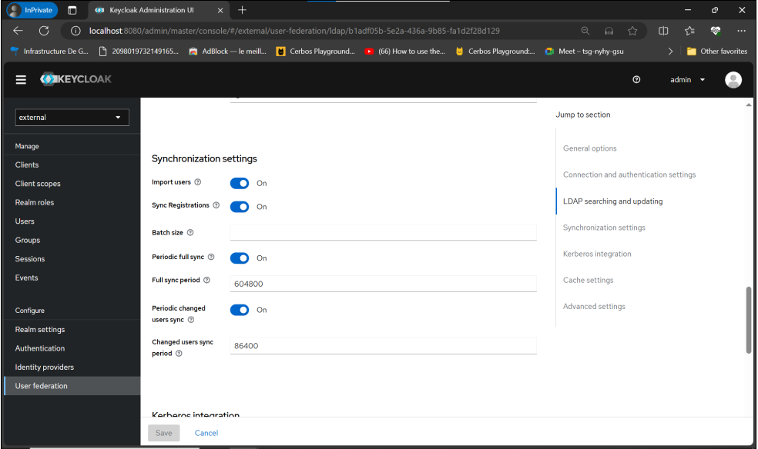

*Figure 4.24: Configuring LDAP Connection Parameters*

**-Configuration backup and initial synchronization**

After saving the configuration, we can initiate the initial synchronization of all users from the LDAP directory to Keycloak.

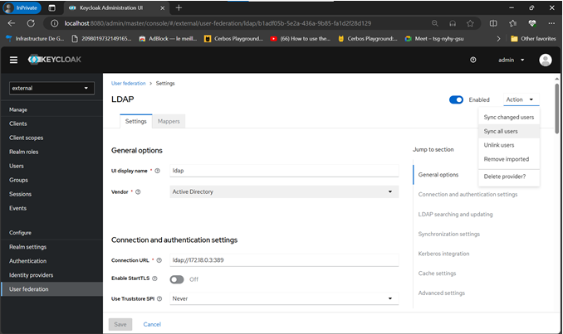

*Figure 4.25: User Synchronization*

**-Checking synchronized users**

Once the synchronization is complete, we can view the imported users in Keycloak.

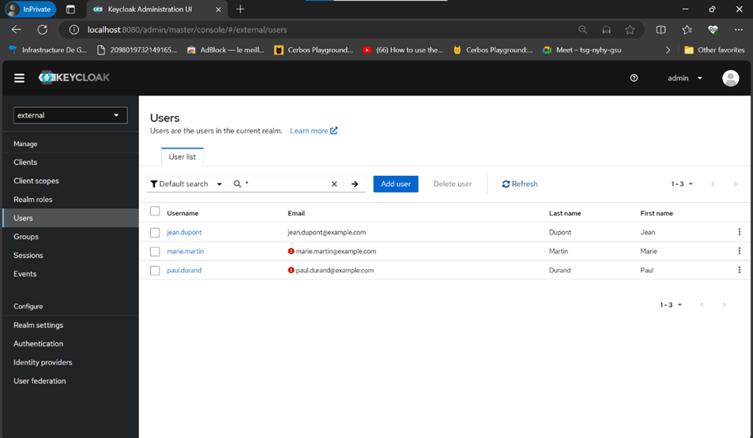

*Figure 4.26: Lists of users imported through federation.*

**-Default attribute mapping**

Keycloak propose des mappages par défaut pour certains attributs utilisateurs. Ils peuvent être consultés dans la section « Mappeurs ».

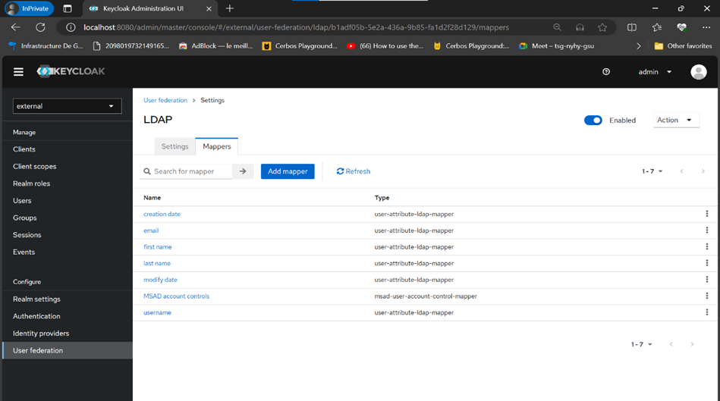

*Figure 4.27: Mapping User Attributes*

**-Credential management**

Identifiers (passwords) are managed directly by the LDAP directory. Keycloak does not store LDAP user passwords locally.

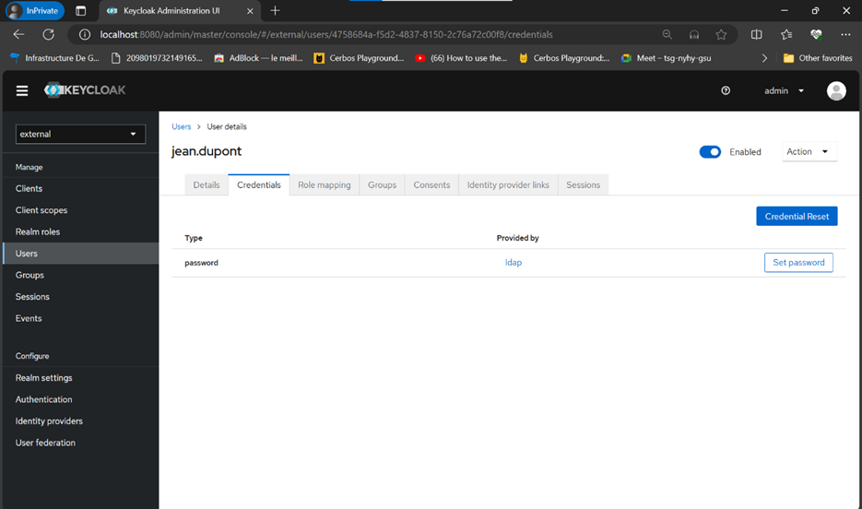

*Figure 4.28: LDAP-Managed Passwords*

**-MFA configuration**

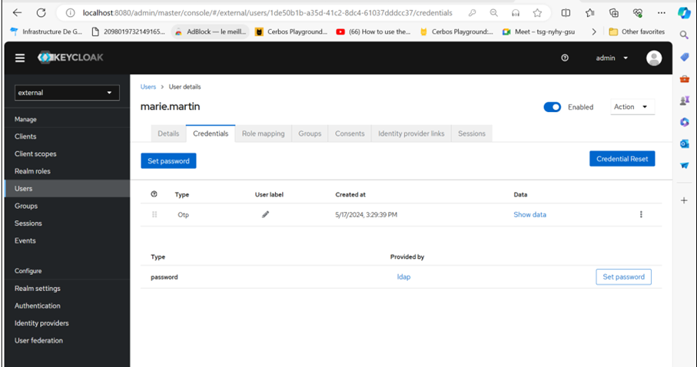

*Figure 4.37: Configuring MFA at the User*

Employees who use the same password for their personal and work accounts are protected from identity theft.

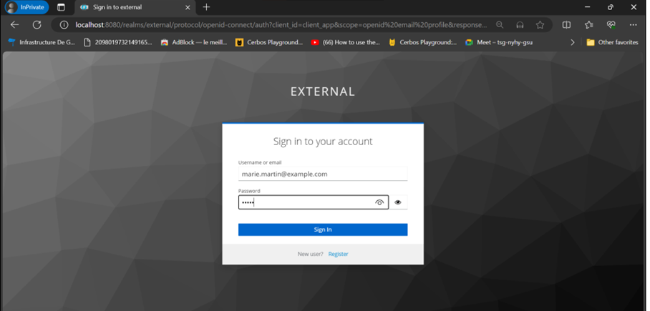

*Figure 4.38: User Authentication Interface*

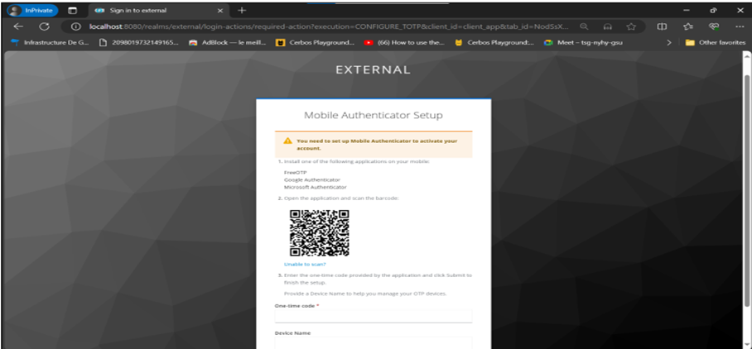

*Figure 4.39: User Request for MFA Configuration*

Even if an attacker steals the employee's password, they won't be able to access X-Financials’ systems without the additional verification code sent to their phone. Here the user is prompted to scan the QR code using a One Time Passcode (OTP) app, we have a choice between three apps:

* FreeOTP
* Google Authenticator
* Microsoft Authenticator

In this use case we will use Microsoft Authenticator.

(The following 2 pictures are from Microsoft’s website since the app doesn’t allow screenshots on the phone)

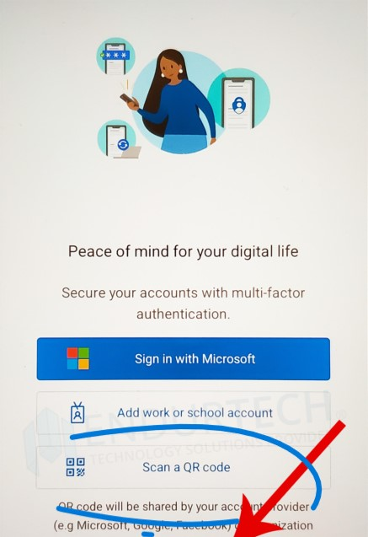

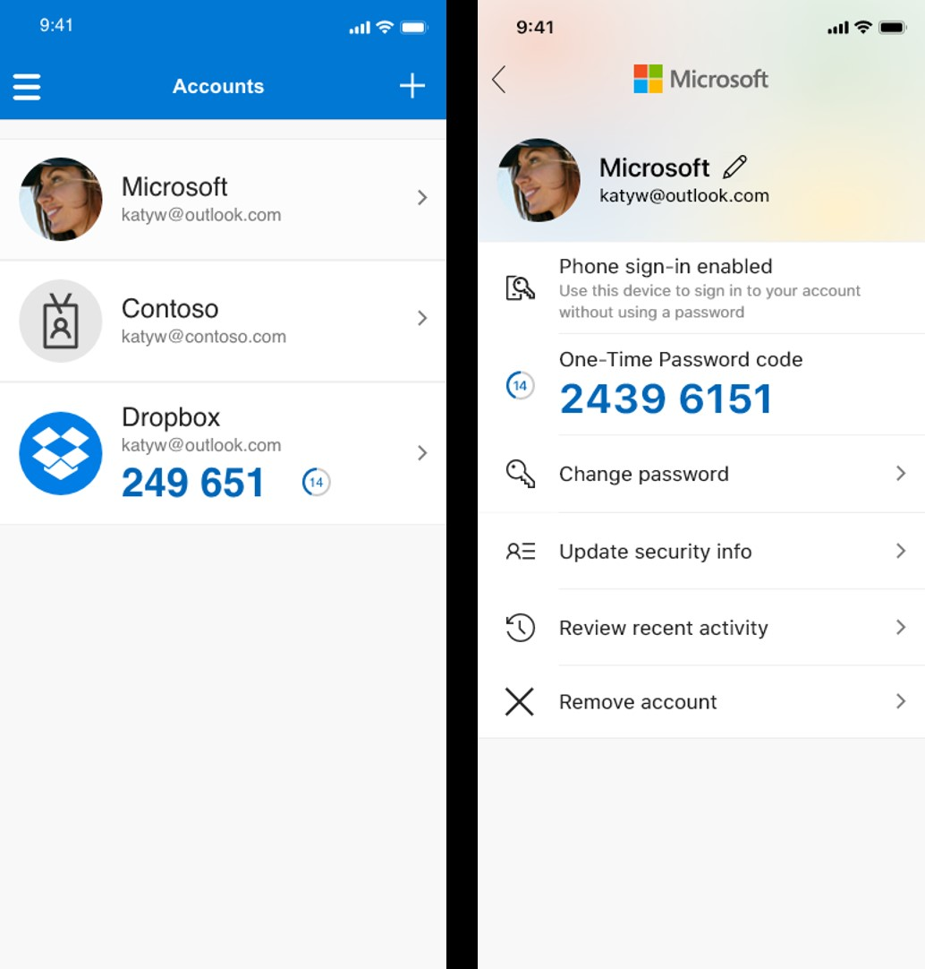

After the user scans the QR code in the Keycloak page with the authenticator app, both will synchronize and the user will appear on the authenticator app, we will be provided with a code that re generates every 30 seconds. To successfully authenticate to Keycloak we type in the code before it expires in the following screen.

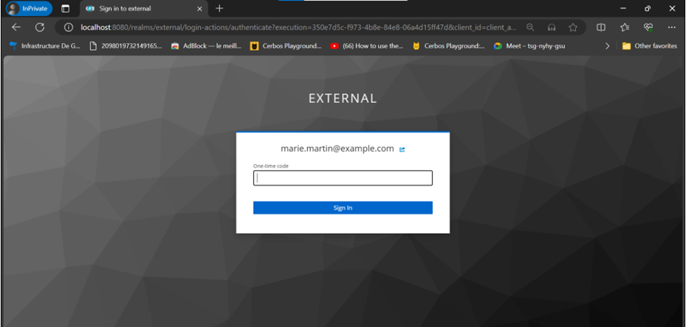

*Figure 4.40: Verification Code Request*

## Application Development

## Application architecture

The application is built with Next.js, a React framework for server-side rendering and static routing. Authentication and authorization are handled by a combination of Keycloak and Cerbos.

## Keycloak API

The user logs in via Keycloak.

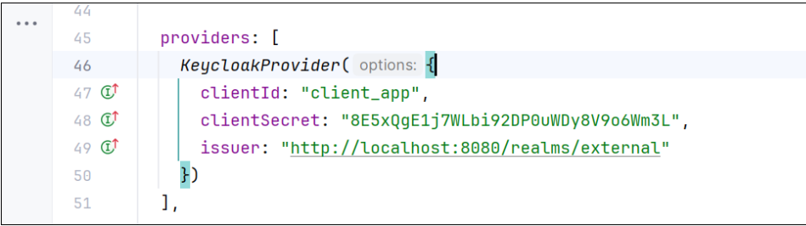

*Figure 4.29: Configuring the Application to Authenticate by Keycloak*

* Keycloak returns a JWT token to the application.
* JWT token verification:
* The app parses the JWT token to extract the user's information.

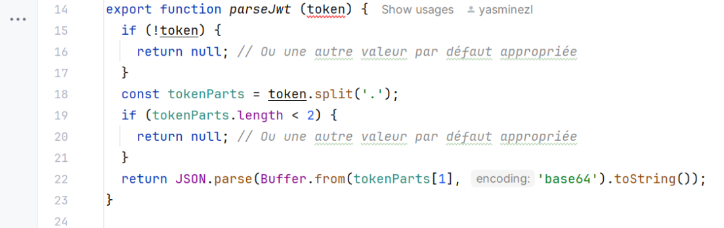

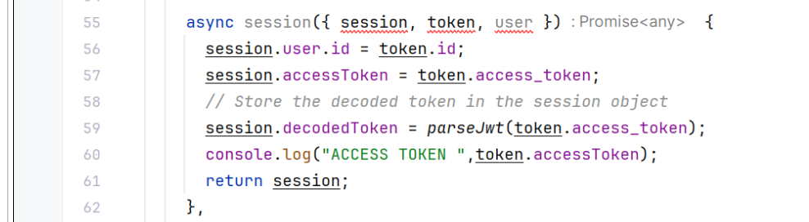

*Figure 4.30: Parsing function of the JWT*

The user's information is sent to Cerbos for a permissions evaluation.

## Cerbos API

Cerbos evaluates the user's permissions based on the policies set.

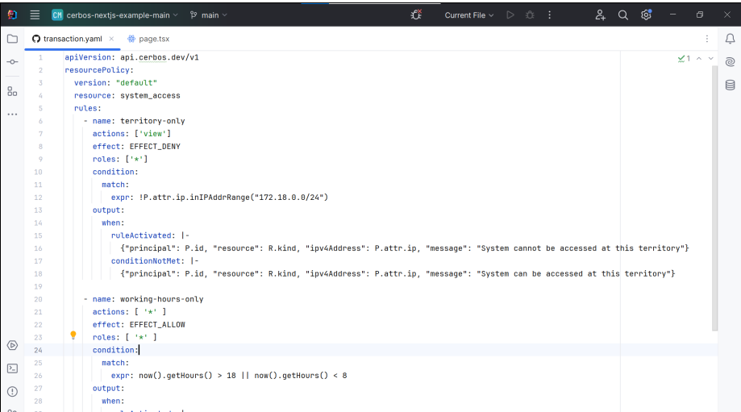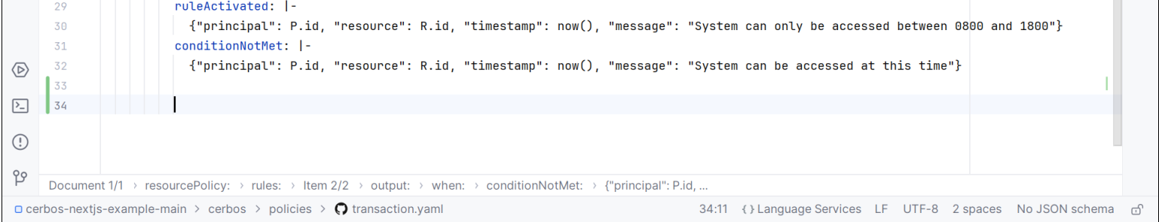

*Figure 4.31: Policy File*

Cerbos sends an authorization decision back to the application.

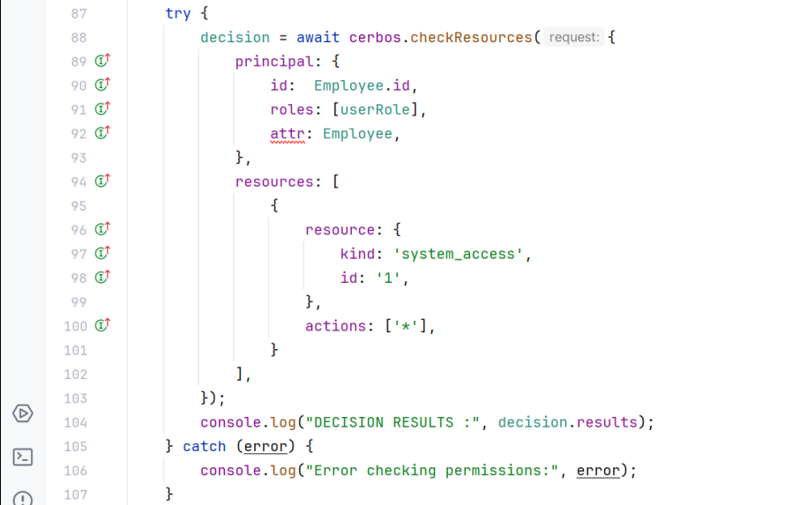

*Figure 4.32: Calling the Cerbos "checkResources()" function*

**Access Control:**

* The application applies Cerbos' authorisation decision.
* The user is authorized or not to access the requested resource.

## Maxmind API

A request is made to extract the user's IP address.

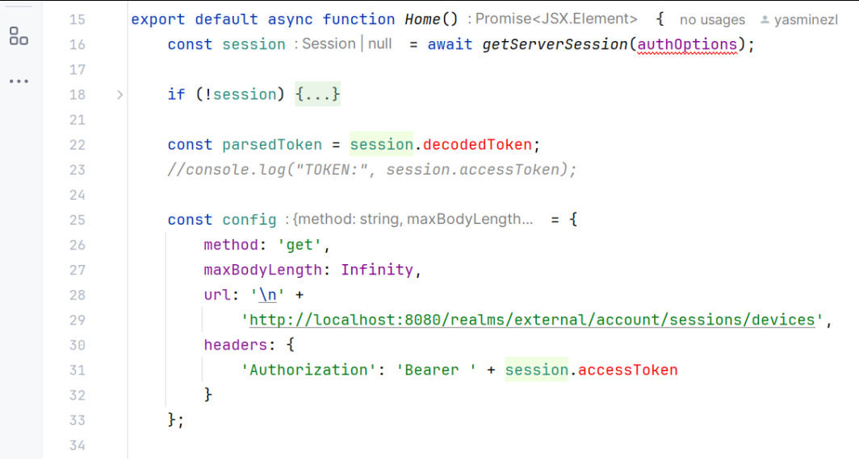

*Figure 4.33: Query to Retrieve the User's IP Address*

The IP address can be used for location-based analytics or access controls.

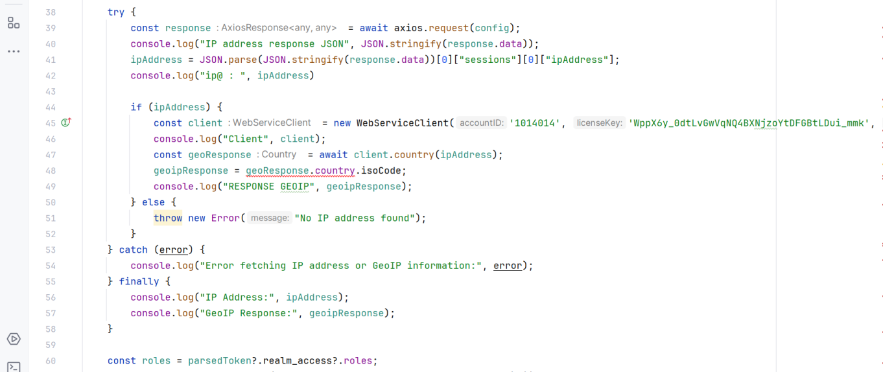

*Figure 4.34: Query to set the user's location using MaxMind*

## Test and Results of the Use Cases

## Use Case 1: Application of the principle of least privilege

**Objective:** To limit user and system access to the resources needed for their specific tasks.

**Results:**

The employee of X-Financials’ finance department only has access to customers' financial transactions and information.

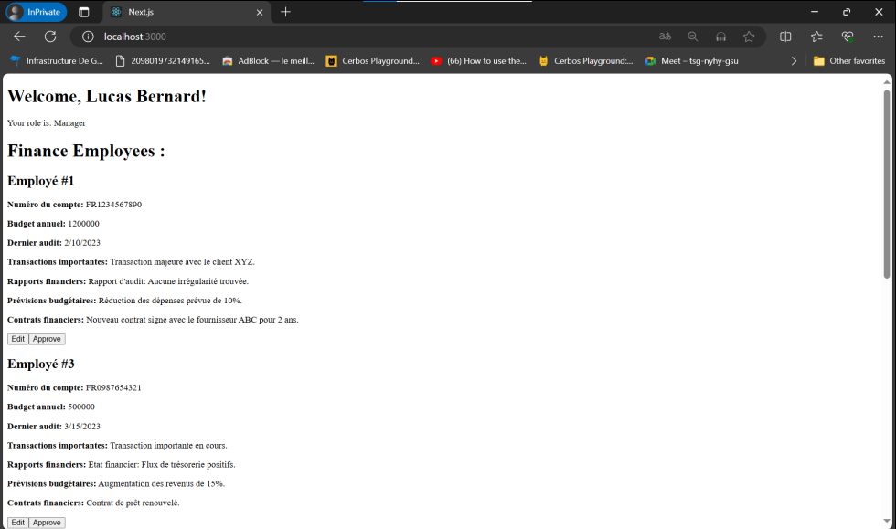

*Figure 4.35: Interface for a "Manager" role user*

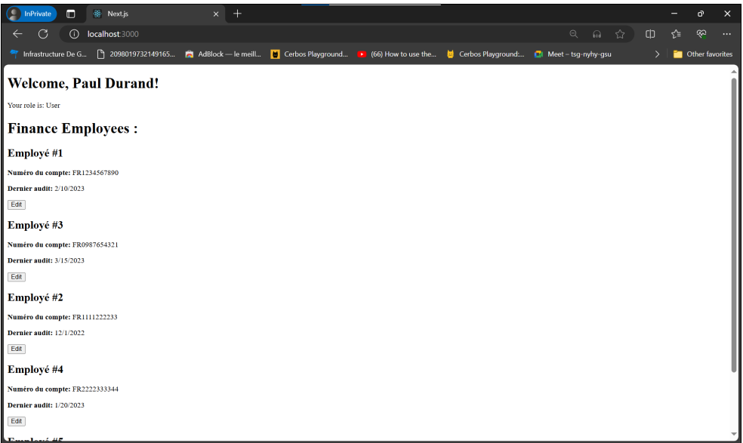



*Figure 4.36: Interface for a User Role User*

Each employee in the department only has access to the data they will need.

**Benefits:**

* Reduced risk of cyberattacks by limiting access to sensitive data.
* Improved compliance with data protection regulations.
* Simplified access management and permissions.

## Use Case 2: Context based access control

**Objective:** To assess the risk of sign-in attempts based on context, such as location, device, and time of day.

**Results:**

* Implementing context-based access control in the Zero Trust architecture.
* Employee X in the HR department, who usually logs in from his PC in Morocco, is trying to log in remotely from a new device and from India.

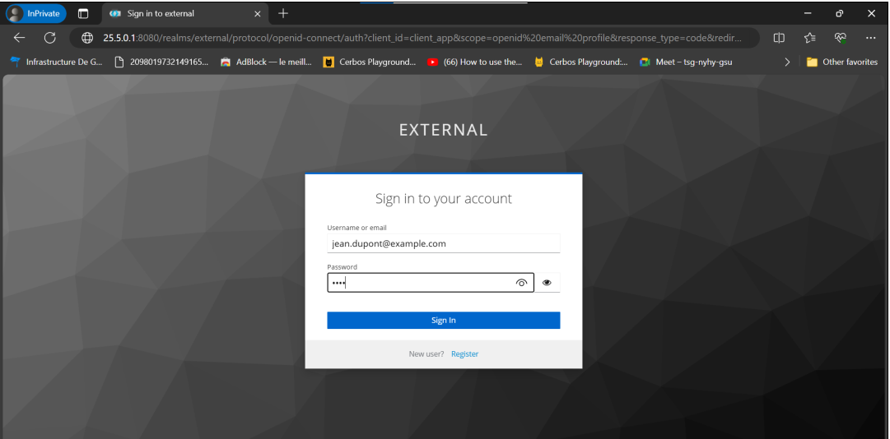

*Figure 4.41: User Authentication Interface*

The Zero Trust system evaluates X's login attempt as risky and blocks him from accessing the system.

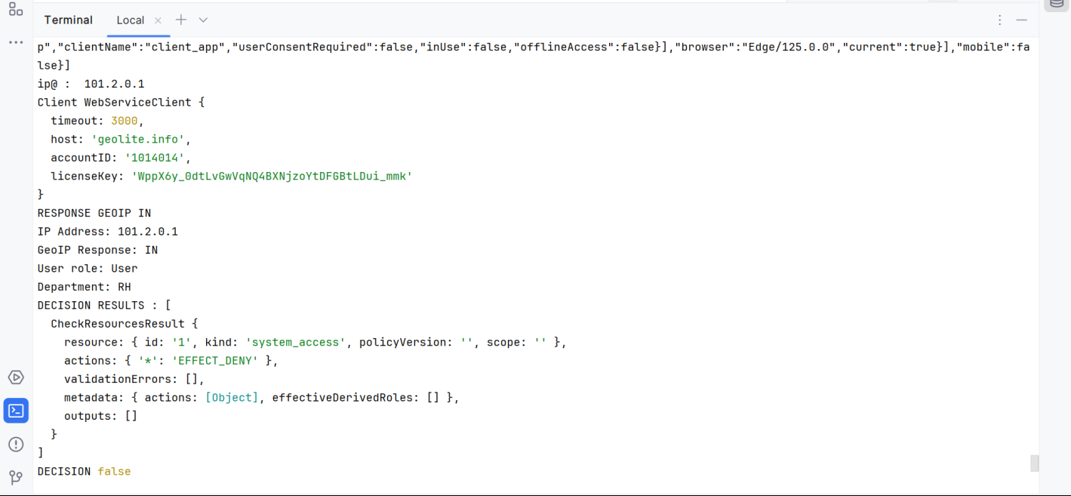

*Figure 4.42: Detection of the user's location and return of the decision from Cerbos.*

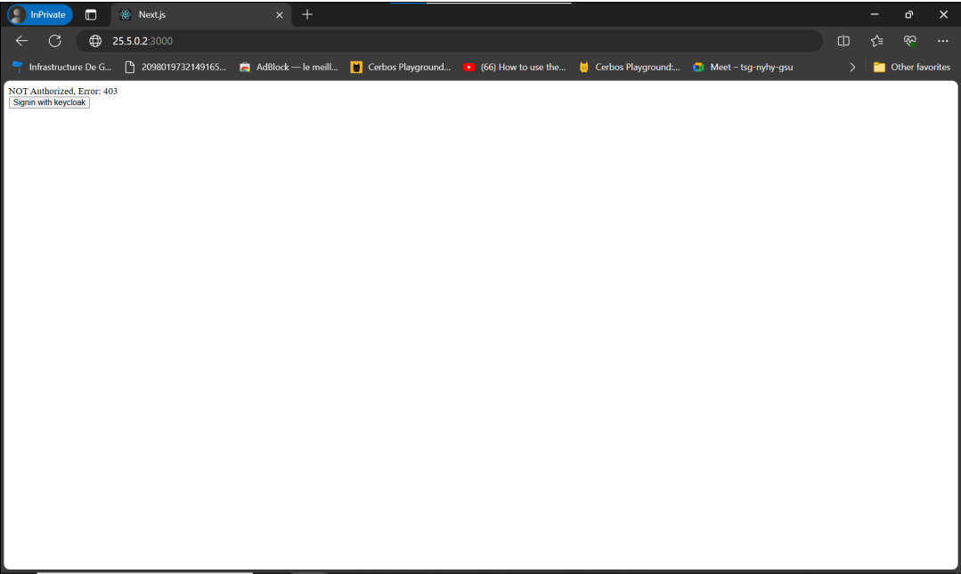

*Figure 4.43: Unauthorized access to the user*

**Benefits:**

* Protection against fraudulent login attempts from unknown locations or devices.
* Detecting behavioral anomalies that could indicate malicious activity.
* Improved protection of sensitive data.

## Use Case 3: Authentication using MFA.

**Objective:** To strengthen access security by requiring additional authentication beyond the password.

**Results:**

Implemented a multi-factor authentication (MFA) system for all users.

**Benefits:**

* Increased protection against stolen password attacks.
* Reduced risk of phishing and phishing.
* Improved trust in user identities.

**Conclusion**

This chapter detailed the architecture and implementation of the application using Cerbos and Keycloak, highlighting the crucial steps of initial configuration and integration. By properly configuring Cerbos and Keycloak, we were able to establish a robust infrastructure for policy decision management and user authentication. The use cases illustrated demonstrate the practical benefits of this approach with a decentralized approach to authorization, such as limiting access, securing authentication, and implementing context-based access control. This implementation strengthens security, improves regulatory compliance, and simplifies access and authorization management across our organization.

# Overall conclusion

In conclusion, this report took an in-depth look at the fundamentals of IT system security, with a particular focus on the Zero Trust approach. We started with a study of the Zero Trust framework, how it can help organizations comply with different regulations like RGPD and NIS 2 and how it can help against comment cyber-attacks (phishing, lateral movement, etc..). Then we created a benchmark of the solutions available on the market, which helped identify best practices and emerging technologies in the field of identity and access management.

Then, we proposed a Zero Trust architecture adapted to the specific needs of our demonstrator. This architecture is based on a strategic approach to policy-based access control and strong authentication. We have presented in detail two key solutions in this architecture: Cerbos and Keycloak. These platforms offer advanced features for access policy management, user authentication, and data security, helping to create a zero-trust environment where every access request is thoroughly evaluated.

To illustrate the effectiveness of our architecture and the solutions implemented, we have studied several use cases, highlighting the concrete benefits of the Zero Trust approach in protecting sensitive data from cyber threats.

Finally, we conducted practical tests of our architecture in a controlled environment, demonstrating its effectiveness and reliability in real-world situations.

In short, this report highlights the growing importance of the Zero Trust approach in securing IT infrastructures against digital threats. By taking a proactive approach focused on zero trust, organizations can strengthen their security posture and protect their sensitive data from cyberattacks.